JUNE 2013 CANBERRA GANG-GANG SURVEY

John Leonard

Address for correspondence: calyptorhynchus@gmail.com

Background
Canberra birdwatchers were invited to submit reports of Gang-Gang sightings and aural records, and nil reports, from the month of June 2013. Records were accepted from the Canberra urban area and nature reserves close to urban areas, but not further away. Nil records were accepted for specific birdwatching trips undertaken in the Canberra urban area and nature reserves close to urban areas, but not for the absence of Gang-Gangs in the suburbs.

The aim was to continue the measurement of Gang-Gang Cockatoo abundance in the ACT using a survey methodology established in the June 2012 survey (Leonard 2012).

Results
A total of 147 records were received for the month from 30 observers. Of these 119 were positive and 28 were nil reports. Of the positive reports 24 were aural records and 95 sight records. 308 individual Gang-Gangs were reported, although this total will include multiple sightings of the same individuals.

The survey attracted approximately half the observers that it did in 2012, and approximately half the number of records were reported. The total number of individual Gang-Gangs reported was only 38% of 2012 records, though this is probably due to observers not reporting large numbers of Gang-Gangs visiting garden feeders as some observers did in 2012.

The metric which can be reported from these sightings, and which can repeated from year to year, is
Number of records – nil records
Number of reporters

Giving the result 3.96 (2012 result 4.83).

64 records out of 119 sight records broke down the birds by sex and/or age.

Discussion
Positive records were spread across the whole month. There was a weak correlation between number of sightings and weekends, but not with weather (the weather in June 2013 was mainly cold and clear with few rainy days).

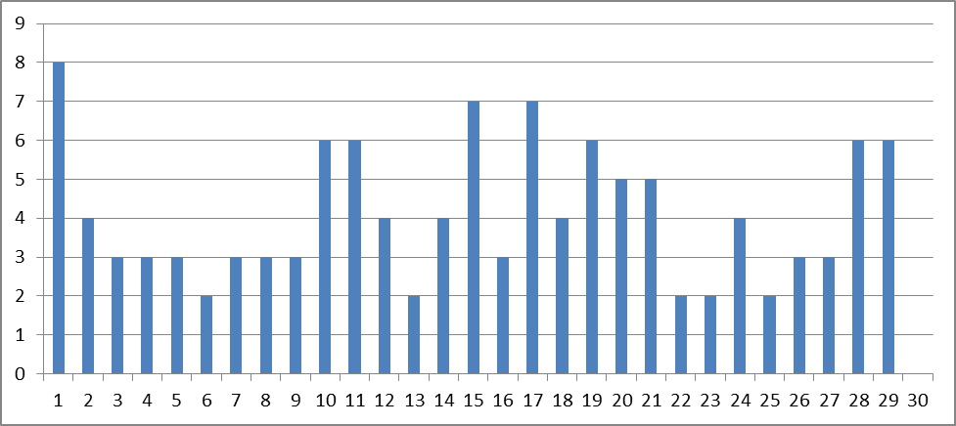

The distribution of sightings was recorded by suburb. The suburbs with the highest number of records were

ANU | 6
Aranda | 12
Cook | 9
Dickson | 6
Garran | 7
Griffith | 22
Hughes | 26
Watson | 8

This list differs considerably from the suburb list published after the 2012 survey. The differences between the two can be put down to a different cast of observers between the two years. The only suburb with high numbers of observations between the two years is Hughes, reflecting the records of John Leonard (and one or two others) in both years.

Apart from this, there were other suburbs with low numbers of records. No records were received from any of the Tuggeranong or Gunghalin suburbs, and none from the Belconnen suburbs west or north of Lake Ginninderra. Weston Creek had a few records. Compared to last year there were more records from the suburbs north of Ainslie and east of Northbourne Avenue. There was only one positive record from the Australian National Botanic Gardens, of birds flying over.

Although the distribution of the records differs from 2012, the inner north and inner south suburbs continue to be the hot spot for Gang-Gang sightings.

As noted, over half of sight records broke the birds observed down by age and/or sex. The most common combinations of Gang-Gangs sighted were a pair with one accompanying immature (28) and male/female pairs (26).

The largest groups reported were 15 observed in Dickson by Christine Ledger, 13 observed by Yarden Oren in Red Hill suburb (possibly a pre-roost gathering) and 9 observed by John Leonard in Hughes.

It is to be expected that Gang-Gangs occurrence will be governed, at least in part, by the availability of food sources. In contrast to 2012, only one series of records in the present results were from a bird feeder. Apart from this there were several references to Gang-Gangs feeding in Eucalypts. There was one record of feeding in a hawthorn (Crataegus) and one in an oak (quercus) ‘possibly feeding on scale/mold/aphids? On leaf surface as other cockatoos have been doing.’

Movements of Gang-Gangs were mentioned by some observers. However there was not enough data to make any firm pronouncements about significantly daily movements of birds or likely roosting sites.

Status of Gang-Gangs in the ACT Urban Area
In the report on the 2012 Survey the conclusion was hazarded that the Gang-Gang population of urban Canberra is around 150 individuals, with several population groups faithful to certain suburbs (perhaps 40 in the inner south (Deakin, Hughes), 40 in the inner north (ANU, O’Connor, Turner) &c), and that the likelihood is also that these observations largely represent sightings of resident local populations, and not the winter visits of a wider regional population that breeds in the Brindabella Ranges or further afield.

Nothing in the records from 2013 would call these conclusions into question, other than suggesting that Griffith may host another population comparable to the Hughes/Deakin population, or that these birds roam as far as Griffith, and that a smaller concentration may be present in the Dickson/Watson area.

List of Observers
Thanks to:

Alison Mackerras | Kelly Debono
Ann Eldridge | Lee Philip
Anne Carrick | Lucy Randal
Barbara Allen | Maurits Zwankhuisen
Chris Davey | Michael Maconachie
Christine D | Muriel Story Edwards
Christine Ledger | Oliver Leonard
David Rosalky | Peter Mellor
Dianne Lockie | Robin Hide
Elizabeth Compson | Robin Hide
Harvey Perkins | Suzanne Edgar
Isobel Crawford | Tony Willis
Jean Casburn | Wayne Gregson
Jenny Smits | Yarden Oren
Kathie Walter and John Goldie

References

Leonard, John ‘Gang-gang Survey Canberra June 2012’. Canberra Bird Notes 37 (2) June 2012: 95-99.

