Jerrabomberra Wetlands
Open Day

Sunday 28 April 2013, 9.30 am – 2 pm
Jerrabomberra Wetlands, 2 Dairy Road, Fyshwick
Head out to the Jerrabomberra Wetlands Open Day on Sunday 28 April and enjoy a day of free fun filled activities for the whole family to enjoy.
The event includes a number of displays, guided walks, bird watching, crafts and face painting. There will also be a group cleanup of the wetlands at 9.30 am and 11.30 am.
Enjoy a bike ride through the Jerrabomberra Wetlands, pack a picnic or treat the family to a sausage sizzle.
Kids will love exploring a Rural Fire Service truck and completing the Riversmart quiz which will involve answering a number of questions along a scenic walk through the wetlands.
This year’s event focuses on learning about the wetlands and preserving their beauty. There will be a number of presentations tackling topics like future plans for the wetlands and the birds of the wetlands.
The Open Day is an initiative of the Jerrabomberra Wetlands Board of Management. It is proudly supported by the ACT Government.
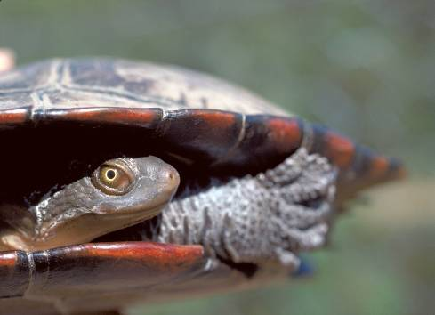
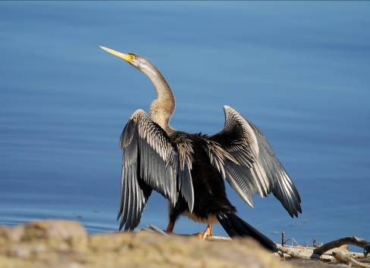
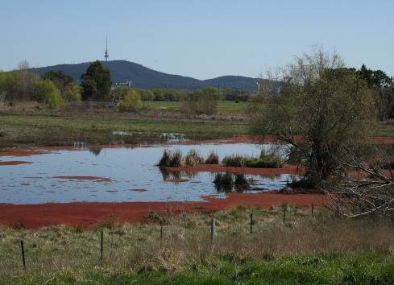
Want to get involved and volunteer at the wetlands? Become a ‘Friend of the Jerrabomberra Wetlands’ by emailing friendsofjerrawetlands@gmail.com

