Jerrabomberra Wetlands Family Fun Day
11 am – 2 pm, Sunday 5 February 2012
Jerrabomberra Wetlands, 2 Dairy Road Fyshwick

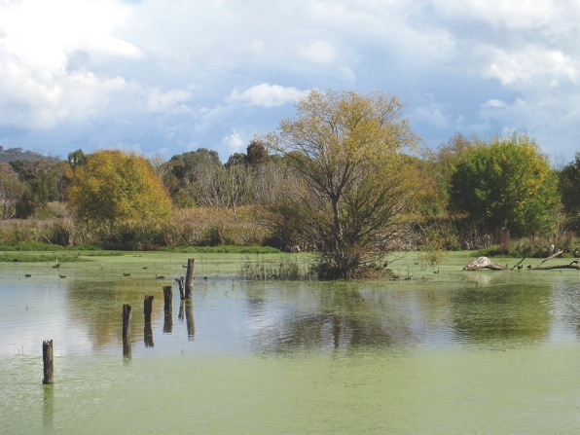
Photo by Big Island Graphics

A fun day out for the entire family in celebration of World Wetlands Day!
There is something for everyone with a jumping castle, face painters, parachute games, a patting zoo and the largest ibis bird you'll ever see.
Take a walk through the wetlands and enjoy unique wildlife in their natural habitat. Bring your binoculars to spot a variety of native birds and get some bird watching tips from the experts.
You can also get up close and personal with a corroboree frog, talk to a ranger and become a fire fighter for the day in the Rural Fire Service truck.
Visit the information stalls, learn about the future plans for the Jerrabomberra Wetlands and enjoy a guided bus tour to rarely seen sections of the wetlands.
Pack a picnic or enjoy the sausage sizzle and ice creams stalls.

For further information or in case of wet weather
call 13 22 81 or visit www.tams.act.gov.au


The Family Fun Day is an initiative of the Jerrabomberra Wetlands Board of Management. Proudly supported by the ACT Governement.

