Central Canberra Gang-gang Census 1st August 2010

Background

A census of the central Gang-gang population was arranged for Sunday 1 August 2010, from 11am-12pm. The idea originated in an online disagreement between two Canberra bird-watchers over the size of the winter Gang-gang population in central Canberra, one participant favouring a low figure of 50 birds, the other a high figure of 250.

The winter population of Gang-gangs in urban Canberra is well-known (COG 2010, Veerman 2002). What has hitherto been lacking is absolute measure of the population derived from a Census on a particular day (rather than from surveys such the Garden Bird Survey which has a monthly time-frame for reporting).

Methods

The time of day was chosen from knowledge of Gang-gang and other cockatoo behaviour; it was anticipated that at this time the Gang-gangs would be feeding in groups and not flying around. This would help to eliminate duplicate counting of birds.

Observers were recruited from the canberrabirds mailing list and selected or were assigned areas to survey during the Census period. Central Canberra was designated as the likely number of volunteers was not anticipated to be large enough to cover a wider area and Central Canberra is thought to have a more concentrated population of Gang-gangs than other urban areas of the ACT (Veerman 2002).

The following areas were surveyed during the Census:

- NW O’Connor, O’Connor Ridge
- suburban Turner
- suburban Ainslie
- Mt Majura fringes
- CSIRO Black Mountain area
- ANU Campus
- Australian National Botanic Gardens
- Campbell
- Commonwealth Park
- Black Mountain Peninsula
- Weston Park
- Parliamentary Triangle
- Telopea Park
- Narrabundah eastern boundaries
- suburban Forrest (north-eastern Red Hill)
- suburban central Griffith
- Narrabundah/Griffith suburb
- southern Red Hill
- northern Red Hill and Deakin
- north-western Red Hill
Had more volunteers been available they would have been assigned to successive suburbs further out from the centre.

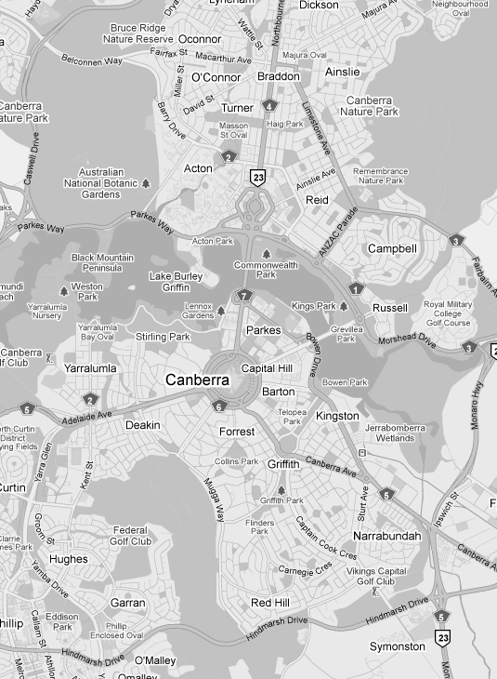
Central Canberra
Courtesy of Google Maps.

Observers were asked to move around in their area for the hour, noting groups of Gang-gangs, their location, and their composition (male/female/immature male). Observers were also asked to note Gang-gangs heard calling but not seen, and Gang-gangs flying (with time and direction, to help eliminate duplicate reporting).

Results

The morning of 1 August 2010 saw a cold front crossing the ACT; before the Census period and up until 11.45 there were cold gusty north-westerly winds blowing, and in addition at 11.45 rain began to fall. These were not ideal observing conditions.

All areas surveyed during the Census recorded nil returns except for Commonwealth Park, where 9 birds were observed (4 males and 5 females), and Griffith (Flinders Way), where 3 birds were observed flying over.

In addition 3 birds were observed flying over Forrest shortly after the Census period (these may have been the same birds observed earlier over Flinders Way).

Discussion

12 Gang-gangs observed in the entire central Canberra area supports the lower figure (50 birds) suggested as the winter population of Gang-gangs in central Canberra. However, anecdotal evidence suggests a higher number of birds are present in the area in winter (including the author’s daily experience of Gnag-gangs in the Hughes area). In the poor weather conditions it is likely that Gang-gangs were sheltering in dense foliage (as were the Commonwealth Park birds) and so escaped detection.

In addition to the Census a householder in Lyons (the next suburb to the west of Hughes (off the bottom of the left-hand corner of the map), who has reported large numbers of Gang-gangs at their house was asked to note any Gang-gangs present during the Census hour. The householder in Lyons recorded 13 Gang-gangs during Census hour (4 adult males, 4 adult females, 4 immature males and 1 immature female).

Another consideration that might explain the low numbers of Gang-gangs recorded on this Census is that the Garden Bird Survey indicates an earlier peak of abundance for Gang-gangs in the Canberra urban areas, in April and May (Veerman 2002).

The Gang-gang is not a well-studied species and reference works such as HANZAB do not provide overall measures of abundance. The winter concentration of Gang-gangs in central Canberra (and over the wider Canberra urban area) is well-known and is the only significant winter concentration in or near a major urban centre (Barrett et al 2003). If monitoring of this population by census is undertaken long-term it is likely that useful data on the population level locally can be gained. The 2010 Census provides a baseline for further data. It is hoped that this Census can be repeated annually. To test the later winter dispersal hypothesis it would be a good idea if the Census were held earlier in the winter, around late May.

Thanks to all observers: Shaun Bagley, Terry Bell, Elizabeth Compston, Isobel Crawford, Geoffrey Dabb, Lindell Dabb, Felicia Fletcher, Tony Howard, Charmian Lawson, Tony Lawson, Oliver Leonard, Sylvius Leonard, Alison Mackerras, Duncan McCaskill, Terry Munro, Rob Parnell, George Preston, Jenny Rees, Julian Robinson, David Rosalky, Roslind Walcott, Wendy Whitham (and anyone whose name I have inadvertently omitted).

John Leonard

References
Barrett, Geoff et al, (2003). The New Atlas of Australian Birds. Melbourne: Royal Australasian Ornithologists Union.
Canberra Ornithologists Group (COG), (2010). Birds of Canberra Gardens. 2nd Edition. Canberra: Canberra Ornithologists Group.
Veerman, Philip, (2002). Canberra Birds: A Report on the First 18 Years of the Garden Bird Survey. Canberra.

