For sale at the 13th October COG meeting – be early to try them on!
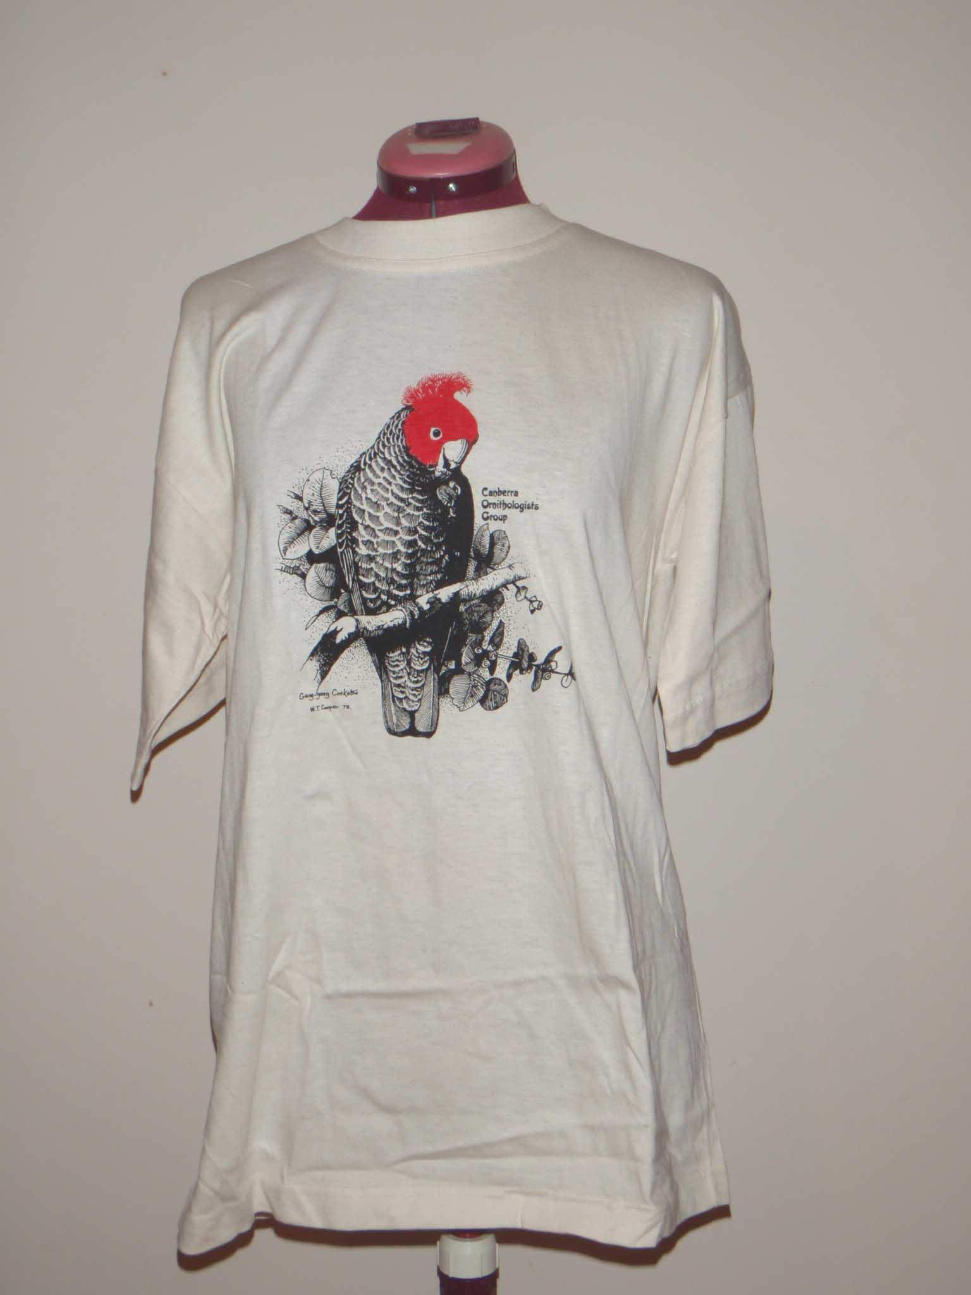
  T – Shirt
   | S | L | XL | XXL | XXXL
  White | 1 | 1 | 1 | 1 | 2
  Grey | 1 | 1
  Bone |  | 3 | 2 |  | 4
 |  | 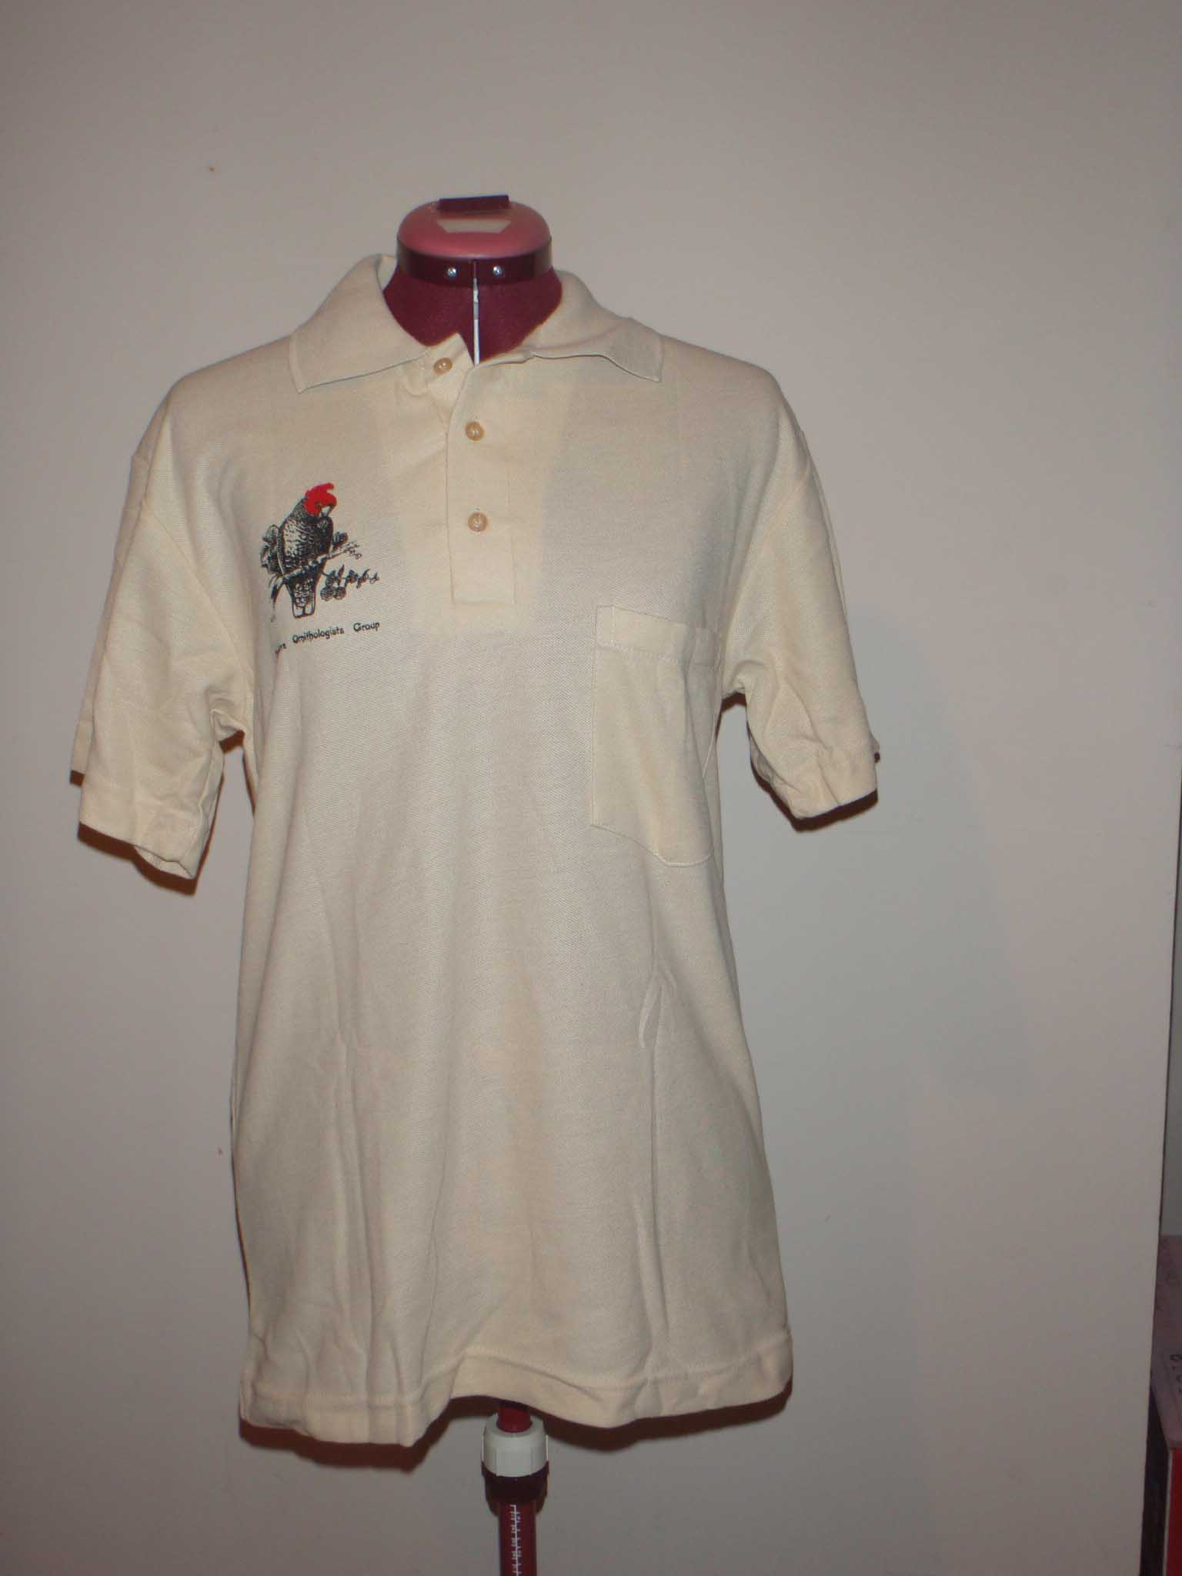
  Polo
   | 14 |  | 26
  Grey | 1
  Bone | 2 |  | 2

