May GBS Notes for Gang-gang
Some GBS-relevant highlights from the chatline for the last few days of April and (most of) May include:
- Yellow-tufted Honeyeater in Gordon;
- New Holland Honeyeaters in O’Connor;
- A sub-adult Olive-backed Oriole in Ainslie (and 4 Wedge-tailed Eagles soaring overhead);
- A Barn Owl harassed by Australian Ravens at a different site in Ainslie (with Pied Currawongs and Australian Magpies observing the spectacle);

Is the sky falling?
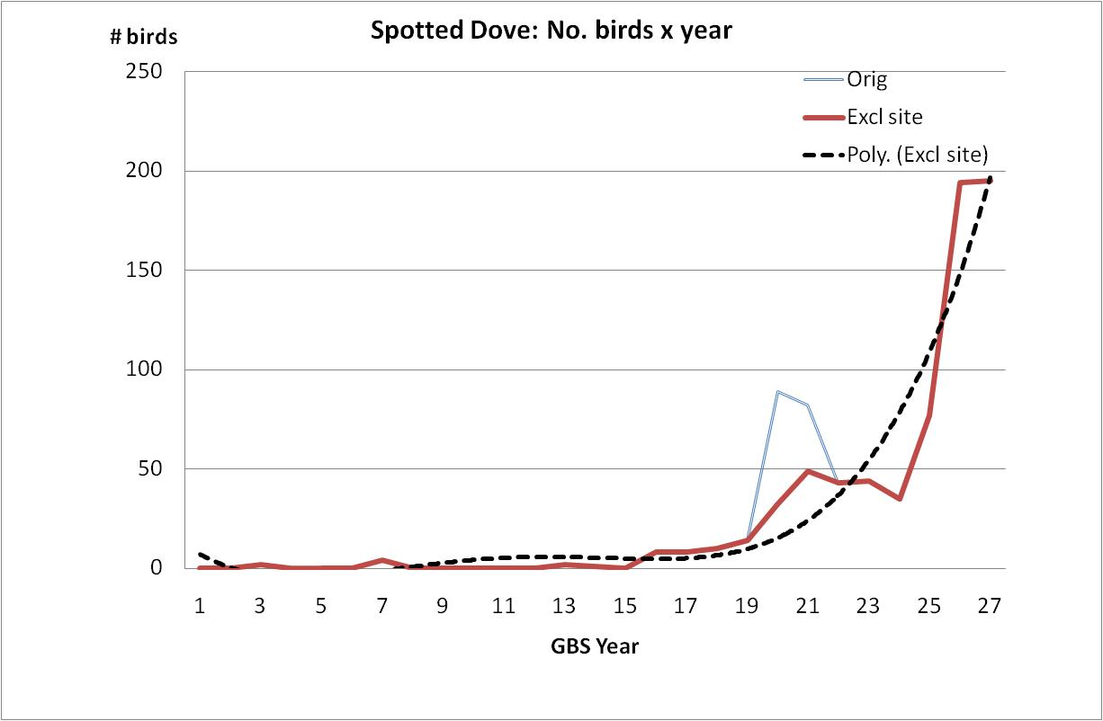
This note was generated by an observation of 4 Spotted Doves at a Holder garden, which seemed to reflect an increasing incidence of this species.
GBS data to year 27 certainly shows the alarming picture presented in the graph. The faint ‘bump’ in years 20 and 21 reflects the large numbers reported at a site in Queanbeyan which was only active for those 2 years. Removing this site makes little change to the shape of the trend line, but increases the correlation to very high levels.
The issues raised by the invasion of Spotted Doves are well discussed in AvIan Whimsy #69 and its preceding Gang-gang article. This graph merely emphasises that the time for concerted action is NOW and that the answer to the question posed in the title is ‘YES’.

Applications of GBS data
A range of observation data has been provided to the ANU PhD researcher concerned with Common Mynahs. Data on Superb Parrots have been supplied to assist COG to contribute to a discussion under the Environment Protection and Biodiversity Conservation Act by the Australian Department of Environment, Water, Heritage and the Arts. A request has also been received from a researcher at Deakin University for GBS data to assist with a PhD project investigating the impact of climate change on breeding patterns.

GBS Redevelopment
A prototype of the new data entry system has been demonstrated, successfully, to the data entry team. The new system will be available for data entry of Year 28 records.

!!!! New Charts !!!!!
Charts for Year 28 will be available for collection at the June Meeting!

