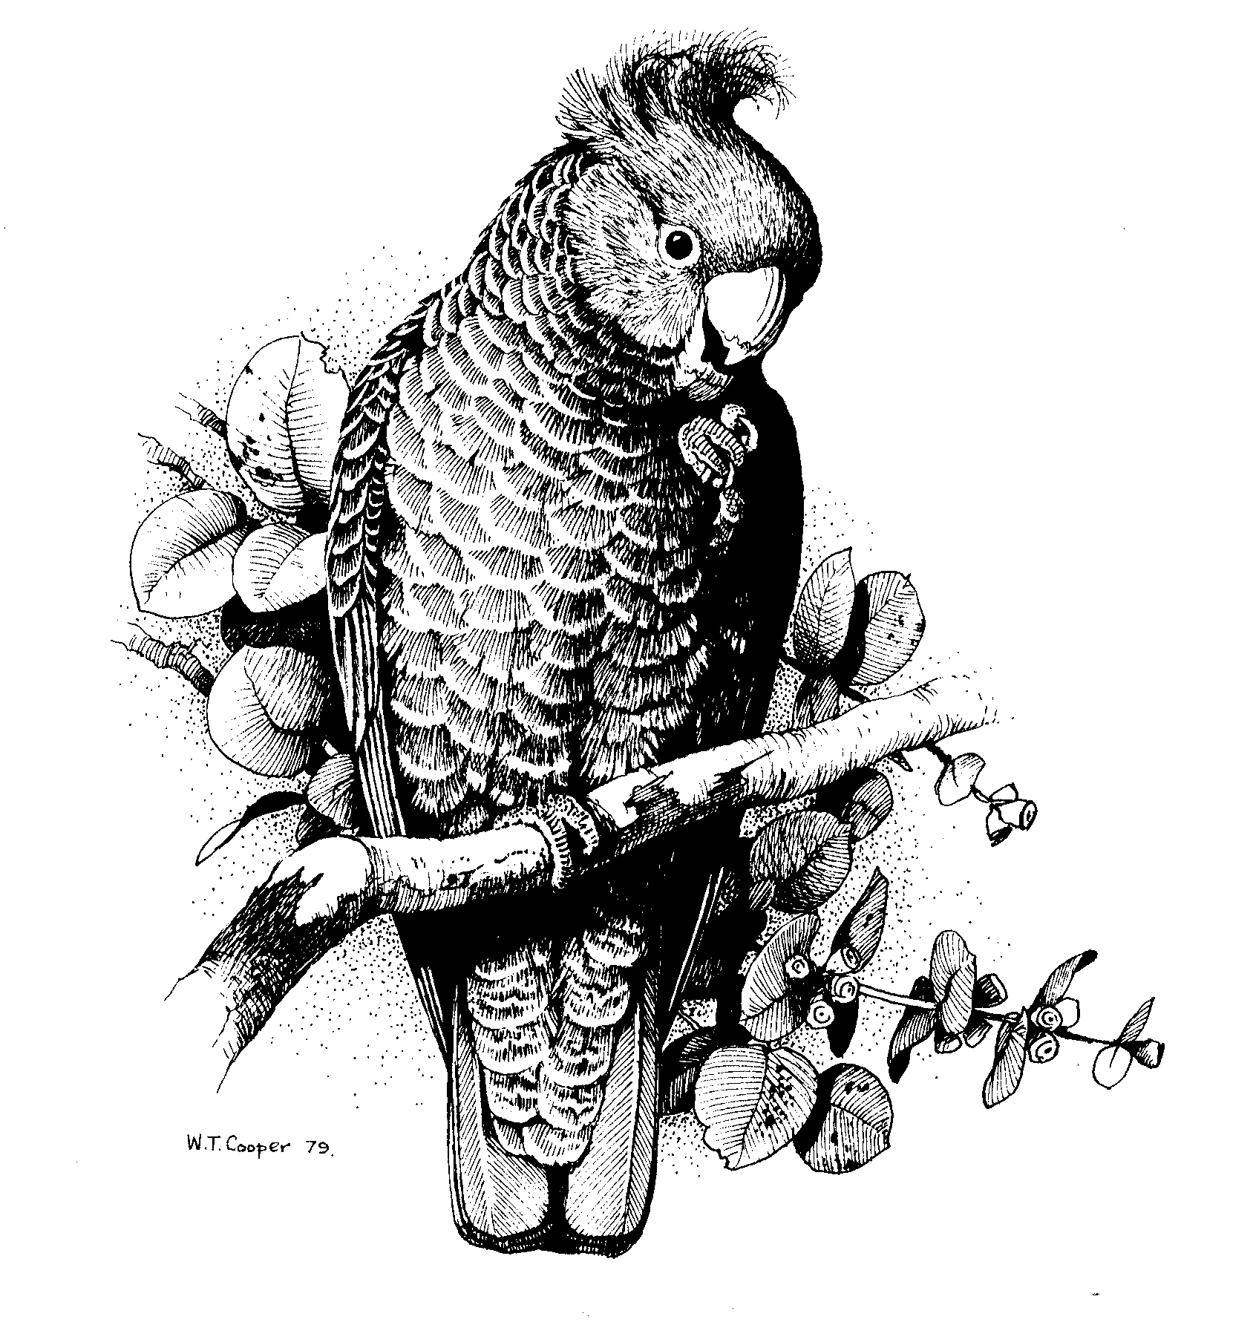Canberra Ornithologists Group
PO Box 301

CIVIC SQUARE ACT 2608

ABN 72 534 628 789

The ACT National Trust
Email: info@act.nationaltrust.org.au

The Social Value of Lake Burley Griffin and its Setting

I am writing in response to the questionnaire you have invited the Canberra community to provide their views on. As there are no fields for free comments, we would like to provide this information for your survey.

The Canberra Ornithologists Group (COG) is a volunteer-based community group with around 350 members whose mission includes the conservation of native birds and their habitats. COG plays an active role in advocating for the protection of native vegetation/bird habitats and for the mitigation of threats to and impacts on native birds.

COG has a special interest in the Jerrabomberra Wetlands in the East Basin of Lake Burley Griffin, a habitat for many species of birds including some rare and threatened species, and lake fringe habitats which provide nesting sites for various species of waterbirds such as cormorants and darters. Some areas have become important regional breeding sites for several species of cormorants and darters which nest in lakeside vegetation. Such areas, although man-made, are assuming more importance for birds in a regime of a drying climate and the loss of some inland wetlands and natural lakes as habitat and breeding areas.

Our members, birdwatchers and nature enthusiasts, place great value on the tranquil setting of the lake overall and of Molonglo Reach and the eastern shores of the East Basin particularly, for low impact recreational bird watching and nature viewing. Our members regularly visit the Jerrabomberra Wetlands area, we hire the quiet electric boats operated by Lake Burley Griffin Cruises (Jim Paterson) for bird watching outings on various parts of the lake (Molonglo Reach, East Basin, Black Mountain Peninsula, Yarramundi Reach, Yarralumla Bay). Occasionally we have birdwatching by bicycle outings around the lake along the bike paths. Some members have used canoes to view birds or do surveys of birds from the water.

We have been concerned in recent years at moves by various planning authorities to develop the lake foreshores more significantly (eg Griffin legacy proposals) and to open up the lake to a greater range of active, noisy motorised or sporting activities. COG’s members would prefer to see the lake prioritised for passive activities, as a place for quieter contemplation and recreational enjoyment by the community, and for the lake setting to remain as far as possible as parklands and green spaces. COG members also value heritage and support the preservation of heritage sites in their appropriate setting.

We believe that Lake Burley Griffin and its very visible birdlife around the shores (eg Swans, Swamphens, Ducks, other waterbirds) has enormous social value for the Canberra community, as well as values for birds and other wildlife, and the lake should not be allowed to be taken over by re-developments which would compromise those values.

In summary, these are specific matters relating to Lake Burley Griffin which have been of particular concern to us in recent years, and on which we have made representations to various Government authorities:
- Moves by the National Capital Authority to ‘open up’ the lake to a greater range of motorised boating and sporting activities, particularly waterskiing in the East Basin very close to the sensitive Jerrabomberra Wetlands and Molonglo Reach
- COG opposed the waterskiing trial pushed through by the former Territories Minister, Jim Lloyd
- our concerns have been around impacts on birdlife which breed and roost in and around the Jerrabomberra Wetlands and Molonglo River; this is the most important wetland in the ACT and a major waterbird breeding and roosting area
- also concerns about the lack of proper environmental impact assessment and lack of proper ongoing monitoring of impacts on wildlife by waterskiing
- the likelihood of an increasing number of sporting/recreational events in the area, and the cumulative human-related impacts on wildlife in an otherwise tranquil, natural area of the Lake.
- The lack of genuine consultation by planning authorities, eg the National Capital Authority (NCA) with the broader community about the use of the lake, and allowing sectional interests (specific lake user groups) to prevail; the issue of lack of genuine consultation by bodies like the NCA has also been manifest in other development proposals regarding the lake, including the Albert Hall area re-development which was vigorously opposed by the community
- It is not only additional activities on the water, but also the very significant impacts of large numbers of people living in and recreating around new urban and boat harbour type developments in areas such as Kingston Foreshores right next to the Jerrabomberra wetlands; so far little has been released publicly about future plans for future East Lake development and how the Jerrabomberra Wetlands will be protected/buffered from these impacts
- Willows removal in known nesting areas of cormorants and darters by the ACT Government has also been of concern, particularly the total clearance of vegetation on the north bank of Molonglo Reach when a more phased approach and the protection of known nesting trees was recommended.

I can be contacted on ph 62546324 (home), 0418 679 847, or email: chris_davey@aapt.net.au if you wish to discuss any matter.

Yours sincerely

Chris Davey
President

21 February 2009

