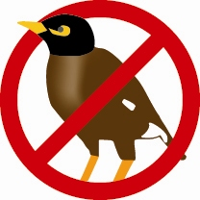

Myna Matters Bulletin # 15

Dear CIMAG Members and Friends

The following provides an update on CIMAG activities.

A New Year begins – and new birds about
The Canberra Indian Myna Action Group Inc Committee hopes that you have all had a very pleasant festive season and that you are very well refreshed and relaxed.

While you have been doing that, the Indian Mynas have been doing their thing, and there are lots of juveniles out and about. Reports of good captures of juveniles are coming in, so if you have a trap, it is time to dust it off and set it up. Let’s reduce the juveniles while they are still young and naïve. As we all know, they can be harder to get when they get older.

A New Logo as well
We are now using a new stylized CIMAG logo — thanks to Marie Lake. Marie has also been doing our artwork and the design for our posters. She has also done the signs that are about to go up on the nature reserve gates advising people about Kate Grarock’s nesting boxes for her PhD research project (see the last Myna Matters Bulletin on our website for info on Kate’s project). So next time you are walking through the reserves where Kate has her nesting boxes, you will see Marie’s work on the gates. Marie has also worked up a template document for one of our brochures that would allow groups elsewhere to put in their own contact details. If any groups outside Canberra would like that, just let us know.

Lots of New Members
In the last Bulletin we mentioned that we were approaching 500 CIMAG members. Well, we are now well over that milestone, but I forgot to keep check on who actually was the 500th person to sign up and to therefore get the “door prize”. So we are holding off giving the golden myna trap prize until we reach the 1000^{th.} At this rate it could be any month now! By the way, we have over 545 people around Canberra / Queanbeyan etc with traps. And we know there are many others with traps. If you have lent your trap to a friend or a mate has made their own by copying yours, can you please ask them to send us their capture numbers — or even do it for them. It is important for us and for Kate’s project.

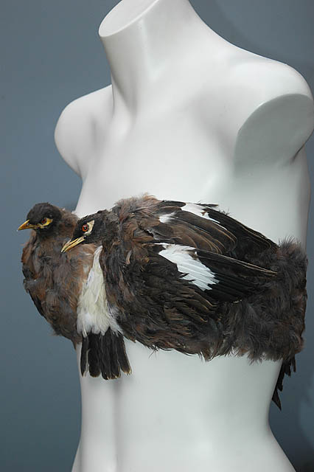
A Strange Use for Mynas #2
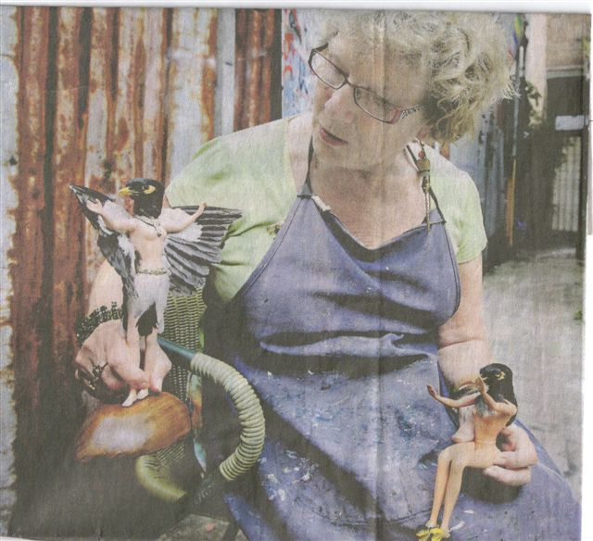
In Myna Matters Bulletin #13, we showed an unusual fashion item (see insert right): well, a member, Phyl Goddard has passed on an article from the SMH with another unusual use of mynas. Not art to my liking, but if stuffed myna heads on dolls is your art piece of choice, then there is a lady in Sydney who has the very thing that you are wanting.

From the subsequent letters to the SMH Editor, she may have a limited market, though.

Traps, Traps Traps: wish we had more
At the moment, the waiting list for traps is over 100. While we have a regular program of working bees to make traps for members, until the new prison opens and their “clients” start making them for us, we are likely to have a longish waiting list for a while. A small committed group of members meet monthly for an evening of trap making (from 4pm – 7pm with beer and pizza afterwards).

If you want to participate in these monthly working bees, could you let me know, please. We can always do with some extra hands. And with the new way that we now make them, no blood is spilt. No trap building experience is needed: at these working bees we just make up the carcass of the traps - subsequently a few people finish them off. Remember, this is not a workshop for the general public where people can make their own trap.

CIMAG Summer BBQ Program – the Roosting Tree Hunt
To assist in locating myna roosting trees for Kate Grarock’s PhD research project, we are intending to hold regular evening BBQs over the next few months with a subsequent suburb walk at dusk to locate roosting trees. These trees will then be the target of the roosting tree trap that Dr Chris Tidemann has designed. At this stage the date and location of the next BBQ has not be set. We will let you know through a notice via the CIMAG email distribution system (the system that sent you this Bulletin). The last effort, a fortnight ago, just happened to be the day that Canberra got dumped on with torrential rain, thunder and lightning. But that wouldn’t happen again!

Kate’s PhD project
Kate reports that some extremely useful information has now emerged from the 210 nesting boxes that she has located in 15 Canberra Nature Reserves. For example, in one of the suburbs where we have no trappers (Kate has identified this as one of the five control – “no trapping” - suburbs), all bar one of the nesting boxes were taken over by mynas, evicting a number of rosellas from the boxes in the process. However, in one of the suburbs where there has been a history of trapping (and hence fewer mynas around) the nesting boxes were generally being occupied by native rosellas. While it is early days in this PhD project, these results give us added incentive to continue with an intensive and sustained trapping effort.

A Change in the Capture Collator
Because of Peter Green’s continuing ill-health, he has had to give up the task of collating the monthly captures for CIMAG. Peter has been a stalwart for CIMAG, and we thank him for his tremendous efforts in the past. We are fortunate that Graham Gliddon has agreed to take on this task. So, in the future, Graham will be sending you the monthly reminder and collating the data. Graham’s email address is: g-gliddon@mysoul.com.au (note that there is a dash, not a dot, between “g” and “gliddon”).

We need more capture records for November and December: quite a few people have yet to send in their monthly returns. Now that the Xmas shopping is over and the turkey eaten, you can turn your mind to the mundane things in life. If you haven’t done so already, can you please send your capture reports for November and December (and now for January as well) to Graham (g-gliddon@mysoul.com.au).

RSPCA – Doing us a service, so lets return the favour
As you know, the ACT RSPCA is a strong supporter of CIMAG’s efforts. So much so, that the RSPCA has disposed of 800 mynas for CIMAG members. It costs the RSPCA to do this: there is the cost of the Lethabarb they use to inject the birds, the cost of disposing of the bodies which cost them $3 per kilo, and of course, staff time. The costs all add up. So a donation to the RSPCA would be much appreciated for this service.

NSW Regional Indian Myna Conference
Things are progressing with the planning of the Southern NSW Regional Indian Myna Conference, to be held at Nowra on 13th May. The EnviroFund has agreed to allow us to direct $5000 of our grant money to this exercise, which we are organising, with the support of the Shoalhaven City Council. We are intending to invite local government and community-action and environmentally-minded groups from Sydney south to the Victoria border to attend and participate in a conference. The program will largely follow that of the highly successful North Coast Indian Myna Conference at Coffs Harbour in 2007 where we all learnt from each others’ experiences. As you will read in the following item, there is a lot happening around NSW at the moment in this campaign, and many different groups are trialing different ways of controlling these pest birds. It will be fascinating to hear what works, what doesn’t and how local government and community-action groups can work together on this problem.

We are interested in identifying groups outside Canberra that might be interested in participating in the conference. If you know of such groups, can you please let me know (email: handke@grapevine.net.au) as we want to invite as many such groups as possible.

Around the Traps – so to speak
As each month goes by, the anti-myna community movement gathers pace. The Tweed area has a program of trapping and trap building now underway. Pamela Gray from the Tweed Shire Council reports that they have 43 traps out in the community, with 76 captures to date. Another 35 traps were about to arrive, and all of those are spoken for.

Ron Smith of Coffs Harbour reports that Coffs Harbour, Bellingen and Nambucca Landcare networks have got Environmental Trust funding of $100,000 over two years to engage a suitable person to co-ordinate, train and assist with the trapping of mynas in the three local government areas. This will be a great boost to myna control in the region. The Coffs Harbour group continues to be quite successful in controlling mynas around there, and Nambucca Heads people are having some success as well. All coastal regions to the north are advancing their myna control programs and some are becoming quite effective. There will be a meeting of all north coast regions in March at Alstonville to advance myna control further.

Around Gosford, the Central Coast Indian Myna Group is going ahead in leaps and bounds: they have been holding 'Youth Apprenticeship" = Work for Dole scheme workshops for trap building, and have continued their successful trapping program in a reclaimed heritage wetlands area in conjunction with the local Landcare Group. They are also working up a roost tree trap and they continue to get excellent TV and media coverage, which is a benefit to us all.

Shoalhaven area: the Men’s Sheds across the council are continuing to supply the local myna network with traps, and capture numbers are building. The Shoalhaven myna network continues to grow, with Meg Bishop of the Huskisson / Woollamia Community Voice, and Max Smith of Mollymook and other coordinators across the region promoting and coordinating publicity and trapping action across their areas. The Shoalhaven City Council is supporting us

in organising the Southern NSW Regional Indian Myna Conference, providing the venue and assisting in other ways. The Mayor, Paul Green, will open the Conference, and he and the council are right behind the effort to reduce the threat posed by mynas in the Shoalhaven.

Far South Coast area has an active group: Jim Shields reports that they have now removed 268 Indian Mynas, which is an excellent number given that mynas are not at the same density down there as elsewhere. The Bega Valley dairy farms are a favoured locale for mynas and the local dairyman have been on the job, with one trapping 48 since June last year.

Wingecarribee area: things are on the move around here as well. The Council regularly sends out information to ratepayers on the problems of mynas, and through Tracey Poulter is getting feedback from the community and helping to facilitate a myna control program. Following a workshop that we gave at Moss Vale — that Tracey organized — trapping is happening around the area, and the Bowral Men’s Shed has offered to make traps for the locals. So far, their captures total 194, mostly in Moss Vale, but not all trappers are sending in their reports. One council staff member captured 82 Starlings, which is an added bonus.

Mudgee district: the Central West Indian Myna Control Group is being very proactive and is tackling mynas before their numbers build up. John McCrea informs us that they have a small number of traps that they are strategically placing in locations where mynas and starlings have been seen. Dunedoo is one target area. More starlings than mynas are being seen (and trapped) around the vineyards and chook yards: for example, an elderly lady cleaned out 88 starlings in a very short time. The group has only been trapping for a month so it will be interesting to hear how it all progresses.

Blacktown City Council: the Blacktown City Council has been funding research at the University of Western Sydney into trapping options. We hope to hear all about it at the Southern NSW Regional Indian Myna Conference.

Myna Trapping Numbers
Because of Peter Green’s difficulties over the past few months, we do not have collated trapping figures later than Oct 2008. But we can report that 577 mynas were trapped in October 2008, bringing our total recorded numbers at that time up to around 21,500. We know that is an under-reported number, so again a plea to any trappers to get their capture numbers in. Not only does it help us make the case to authorities and other doubters that we are making a difference, but it is also vital for Kate’s research project to get as accurate a figure on captures as possible. So can you get your numbers into Graham Gliddon for November, December and January please.

CIMAG News Distribution System

To get onto the CIMAG news email distribution system for news and notices from the CIMAG Committee, just send a blank email to news-subscribe@indianmynaaction.org.au and you will be automatically included on the distribution list. This will be the main way that the Committee will circulate information and notices to CIMAG members and “friends”.

Bill Handke
President
CIMAG

2 Feb 09

