You are invited
to count
Australian White Ibis

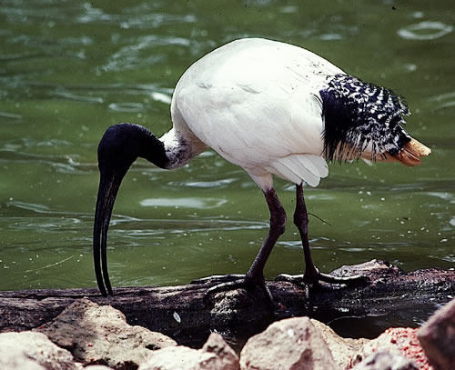

The management of Australian White Ibis on a regional basis requires good knowledge of the NSW population. To help us obtain this “snap-shot” the Parks and Wildlife Division of the Department of Environment and Climate Change (NSW) are organising a state-wide count. This will aid with research involving movements and abundance of ibis and assist with the conservation practices to be put in place.

The Parks and Wildlife Division of the Department of Environment and Climate Change (NSW) request for your participation in this event. You can help provide valuable information on this misunderstood species. Your counts (along with location and time of day) can be faxed, emailed, input straight to the online database, or “snail-mailed” to us.

To help with planning, please RSVP by 9th December where your count will take place to john.martin@austmus.gov.au

When: Sunday, 14th December
Where: anywhere in NSW
How: Report ibis numbers, band colours, nesting, location, etc.
Contacts: Online form: www.environment.nsw.gov.au/surveys/WhiteIbisSurvey.htm
Email: ibis@environment.nsw.gov.au
Phone the Environmental Line: 1300 361 967 Mon-Fri only
Fax: (02) 9585 6555 Attn: Wildlife Licensing and Management Unit
Mail: Australian White Ibis Survey
Wildlife Licensing and Management Unit
PO Box 1967
Hurstville NSW 2220

