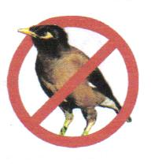

Myna Matters Bulletin # 14

Dear CIMAG Members and Friends

The following provides an update on CIMAG activities.

A successful AGM
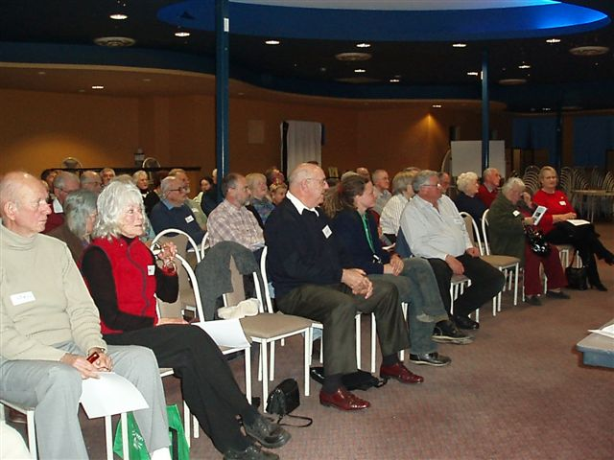
CIMAG had another very successful AGM and Public Information Night back in late August. Over 60 people attended and heard an update on CIMAG activities over the past year and the state of our finances (you can catch up on this from the President’s 2007-08 Report on our website – www.indianmynaaction.org.au). The highlights of the night were the presentations by Professor Tony Peacock, Dr Chris Tidemann and Kate Grarock. Each kept us enthralled with their entertaining but informative talks. Tony, the CEO of the CRC for Invasive Animals spoke of Indian Mynas in the context of other feral animals. He presented a bottle of wine and a T-Shirt (from a dubious source – the RoadKill Café in WA that has the motto “you kill ‘em, we grill ‘em) to Greg Flowers and Daryl King for being the trappers who had removed the most Indian Mynas in the past year. Chris brought us up to date on his research in developing a roost tree trap that holds out the prospect of removing hundreds of mynas in a single event. With a few more refinements it will shortly be put into play. Chris also informed us of research on the most humane way of disposing of trapped birds. The research is pointing to carbon monoxide from a cold car as being the quickest, painless and stress-free method. We look forward to this research being written up as a scientific paper, peer reviewed and then becoming a standard accepted by governments and the RSPCA nationally. This will be important in enabling the mass community-action movement to progress across the eastern seaboard as it will enable a cheap, simple, safe, practical and humane way of disposing of trapped pest birds.
The enthralled AGM crowd
Kate explained to us her PhD project which is now well underway – see the separate item below.

Incidentally, the existing Committee was re-elected unopposed: Bill Handke, President; Bruce Lindenmayer, Vice President; Peter Franklin, Secretary; Anne I’Ons, Treasurer, and Jenny Bounds, Alison Russell-French, Rosemary Blemings, Peter Ormay, and Greg Flowers as committee members. Peter Green will continue to be our technical advisor.

Our thanks to Tony, Chris and Kate and to John Seccombe for managing the election.

PhD Research Project well underway
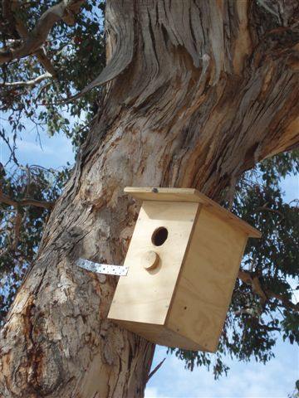
Kate Grarock is well underway with her PhD project on Indian Mynas. She has been a very busy person: making up 210 nesting boxes and erecting them in a number of Canberra’s nature reserves: many of you will have seen these on your walks. They will form a vital part of her research work. The PhD research project involves Kate conducting a removal experiment in Canberra suburbs to see the effect mynas have on our native species. In five suburbs she will remove a “high” number of mynas (with the help of CIMAG trappers and Chris’ roosting tree trap). In another five suburbs she will remove a “medium” number of mynas (with the help of CIMAG alone). She will also use a further five suburbs as a control where no mynas are removed.
One of Kate’s nesting boxes

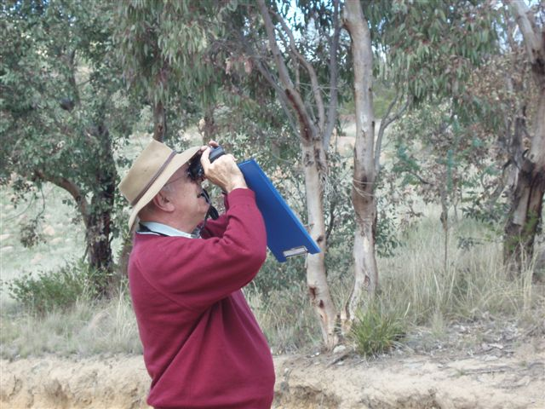
Each of the 15 suburbs will be monitored by transect counts of all bird species present, and through observing the 210 nesting boxes to monitor nesting success of both natives and mynas.

The project started in June 2008 and is planned to continue until September 2010.

This project will build on past research work about the impact Indian Mynas are having on Australian native birds. The project has three objectives: 1) to find the level of myna removal that will lead to the long-term reduction of overall numbers (i.e. not just provide gaps in the population so those remaining can flourish); 2) demonstrate clearly and scientifically the impact mynas are having on native species (to date, the impact mynas have on our natives is largely unqualified; we know it occurs, but not to what extent and which species are most impacted); and 3) observe mechanisms used by mynas that may allow them to recover quickly after removal (perhaps mynas will rear more chicks in removal areas, than those in non-removal areas).
Bruce Lindenmayer, CIMAG Vice President, bird monitoring for Kate’s PhD project

From this project Kate hopes to answer questions on the size of area that needs to be targeted for the removal of mynas. For example, is it feasible to just concentrate on trapping one suburb at a time or do we need to focus on a much larger area? Additionally, an understanding of how mynas adapt to a reduction in numbers may hold the key to ensuring that reductions are long lasting.

20,000 and still counting
We now know that at least 20,082 Indian Mynas have been removed from Canberra suburbs since CIMAG started. This is having a huge impact on total myna numbers. As not all CIMAG members report their captures, and there are many non-CIMAG people who have made their own PeeGees easy-to-make trap, this number could well be around 25,000. This would equate to between 15%-20% of the myna population in Canberra in two and a half years. A quite remarkable and significant result. See the last page for suburb numbers.

MOU with the New Prison

CIMAG members know that we have been overwhelmed with requests for traps since we started this program: and that we have struggled to keep up supply. Well, relief is at hand. CIMAG has now signed a Memorandum of Understanding with ACT Correctional Services —the new ACT prison, the Alexander Maconochie Centre, will make up traps for CIMAG. While we will also continue making up traps for free for people, the new supply of traps from the Maconochie Centre will enable us to more quickly meet the many requests for traps. So if you are one of the 90 people who are on the trap waiting list, please hold on a little bit more: we hope to have one in your backyard before too much longer.

Mynas in the Horse Paddocks
The plague of mynas in our horse paddocks will be the focus of some trapping research. We are still finalizing the details of a pilot project to test the best way of tackling this problem. Myna numbers in the horse paddocks can be very high when horses are given supplementary feed. The mynas worry the horses by sitting on their backs and fouling them. Hopefully our pilot project in 3 horse paddocks will give us the steer on how to deal with this problem. Our initial focus will be in the Illoura Horse Paddocks at Weston Creek, those out at Hall, and the Kaleen or Rose Cottage horse paddocks. The horse agistees are very keen for us to start – and hopefully we will be ready to go very soon.

Around the traps – so to speak

There have been some very good developments on the myna control front across eastern NSW since our last Myna Matters Bulletin.

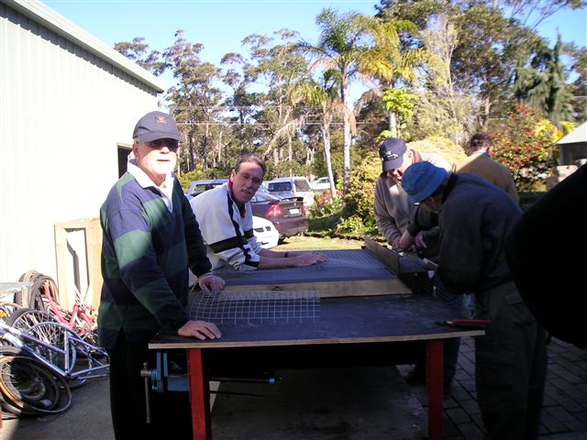
Anna Hernell of the Shoalhaven City Council and Meg Bishop of Husskisson arranged for CIMAG to give presentations and to run trap building workshops at Kioloa and Sanctuary Point. Very good numbers of people turned up and quite a few traps were made at Sanctuary Point Men’s Shed – with almost instant success. Rod Simpson from Husskisson put his trap to work next day and by the time we got back to Canberra he had reported 9 mynas in his trap.

A similar presentation and trap building workshop is to be held at Moss Vale on the 25th Oct, after an invitation to CIMAG by Tracey Poulter of the Wingecarribee Shire Council.
At Sanctuary Point Men’s Shed
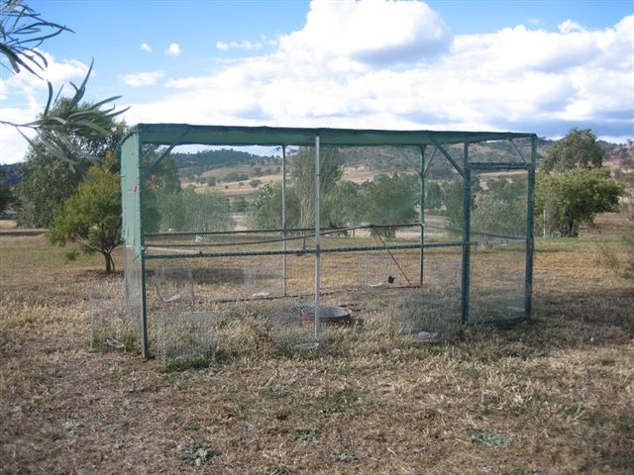
The Tamworth Birdwatchers Group and the Tamworth Regional Council have been working together to tackle the local problem of Starlings and Mynas roosting in the main street and fouling the picturesque street-scape, with excellent success. The crew at the Waste Services Group, TRC, has built a very large trap with 10 of the PeeGees feeding chambers on the perimeter to entice the Starlings and Mynas in, and set it up at the garbage depot. By all accounts it has been a great success and has knocked the pest population down considerably.
The Tamworth Rubbish Dump Trap

The story at Murrumbateman is also very encouraging. Over a year of trapping on the rural properties, perhaps up to 4 mynas were caught in a week, then numbers dropped off to a trickle of possibly 1 or 2 a week - often none. The Murrumbateman Landcare Group then put their traps in the vineyards when the grapes were ripening — within the space of 2-3 days they had captures of 20, and up to 60 over a few weeks. This far exceeded their estimates of the myna population in the whole Murrumbateman area. This has helped them refine their trapping program and might be a lesson for other vineyard regions, such as Mudgee.

CIMAG reaches 500 members
CIMAG membership numbers have now exceeded 500. A group to be reckoned with !

CIMAG News Distribution System

To get onto the CIMAG news email distribution system for news and notices from the CIMAG Committee, just send a blank email to news-subscribe@indianmynaaction.org.au and you will be automatically included on the distribution list. This will be the main way that the Committee will circulate information and notices to CIMAG members and “friends”.

Bill Handke
President
CIMAG

16 Oct 08
Trapping data by suburb: to end Sept 2008

Suburb Aggregate Mynas Suburb Aggregate Mynas
Amaroo 232 Aranda 556
Ainslie 243 Banks 108
Barton 0 Belconnen 31
Bonython 25 Bruce 8
Calwell 109 Campbell 82
Chapman 180 Chifley 172
Chisolm 32 Conder 120
Cook 38 Curtin 503
Deakin 194 Dickson 32
Duffy 608 Dunlop 53
Evatt 116 Fadden 387
Farrer 360 Fisher 512
Florey 38 Flynn 222
Forrest 36 Garran 607
Gilmore 60 Giralang 352
Googong 56 Gordon 247
Gowrie 0 Greenway 0
Griffith 63 Hackett 135
Hall 898 Hawker 198
Higgins 147 Holder 69
Holt 134 Hughes 513
Isaacs 38 Isabella Plains 11 Jerrabomberra 82 Kaleen 465
Kambah 4185 Karabar 13
Latham 168 Lyneham 177
Lyons 581 Macarthur 8
Macquarie 318 McGregor 34
McKellar 40 Majura 1
Mawson 36 Melba 218
Monash 355 Narrabundah 383
Ngunnawal 119 Nicholls 96
O’Connor 10 O’Malley 23
Oxley 4 Page 49 Palmerston 6 Pearce 546 Piallago 4 Queanbeyan 65
Red Hill 95 Richardson 118
Rivett 415 Royalla 0
Scullin 14 Spence 5
Stirling 196 Sutton 4
Swinger Hill 13 Theodore 705
Torrens 182 Turner 24
Wanniassa 517 Waramanga 494
Watson 227 Weetangera 236
Weston 306 Yarralumla 208

