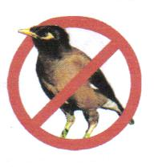

Myna Matters Bulletin # 13

Dear CIMAG Members and Friends

The following provides an update on CIMAG activities.

We REALLY ARE making a difference
It is not our imagination that our activities are having an impact on myna numbers in and around Canberra. The Canberra Ornithologists Group (COG) Garden Bird Survey for 2007 has, for the very first time over its 25 year history, recorded an actual drop in Indian Myna numbers in Canberra. The clear inference being that our trapping program is behind the change. This is exceptionally good news and gives us added incentive to continue with our activities.

PhD Research Project underway
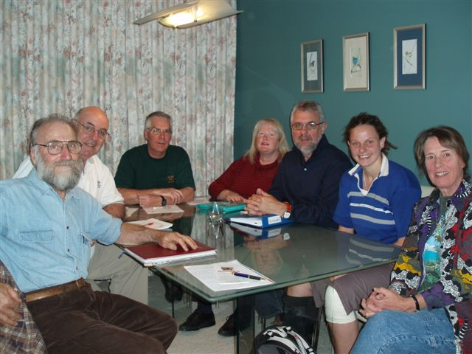
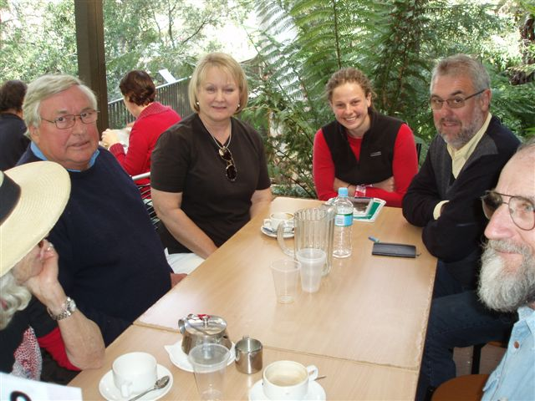
Very exciting news is that the PhD project on the impact of Indian Mynas is now underway. Kate Grarock, the PhD student has settled into Canberra and is in the process of thinking through the issues that she wishes to tackle as part of her thesis. We are very fortunate to have someone of Kate’s capability (she was the top graduate at the University of Wollongong in 2006 and was included on the Faculty of Science Dean’s Merit List for 2006) working on the issue and for Dr Chris Tidemann and Prof. David Lindenmayer involved in supervision and management. The CIMAG committee had a “working” lunch with Kate and Chris, and Kate joined the Committee at one of our meetings. There are many issues that could be explored by Kate in the 4 year research project and it might take a while before the focus of the project firms up. The project is extremely important follow-up research to that of Dr Tidemann and his previous students. We hope it could help in answering the burning question: “are CIMAG activities making a real difference?” It is anticipated that CIMAG members / trappers will have a role in supporting Kate in research field work. So, welcome Kate. We are delighted that you are here. For anyone puzzled as to who all these good looking folk in these photos are, all I will say is that Kate is the youngest looking one and Chris is the learned-looking one.
Kate at CIMAG Committee meeting
Chris and Kate with Committee members

Help in Making Myna Traps

CIMAG members will know that we have been overwhelmed with requests for traps since we started this program to tackle Indian Mynas: and that we have struggled to keep up supply. Well, relief might be at hand soon enough. CIMAG has been discussing with correctional services in the ACT about the prospect of myna traps being made at the new ACT Gaol, the Alexander Maconochie Centre, and at the existing youth detention centre, Quamby. This looks very promising: there are benefits all round. We will be able to more quickly meet the requests for traps (now over 80 again) and the “guests” in the two correctional centres will get the opportunity to develop new skills and occupy their time on a worthwhile pursuit. The Maconochie Centre does not open for a few more months, so it will be a little while before this arrangement could kick off. In the meantime, we have placed an order with the Goulburn Gaol for their “guests” to make up a batch of ten traps. We hope to get those soon.

RSPCA Times
As you know, we have a collaborative arrangement with the ACT RSPCA. The Wildlife Centre of the RSPCA will dispose of trapped mynas for our members. They have now advised that they will accept trapped birds at any time: while they do this as a free service for us, we ask that you kindly show your appreciation of their efforts and their general good work by making a donation to the RSPCA when they dispose of birds for you.

Mynas in the Horse Paddocks
We get reports from time to time that Indian Mynas flock around the feeding / holding yards of the 17 public horse paddocks in the ACT. With that in mind, Peter Franklin, the CIMAG Secretary, and I recently met with the horse agistee contacts for the horse paddocks to discuss a myna monitoring program and possible control activities in these areas. We are interested in firstly getting an idea of which horse paddocks have high myna numbers and then pilot possible control measures in conjunction with the horse paddock managers and the horse owners. It is very early days on this, but as a start Peter and I visited just 4 of the paddocks: the absence of mynas was a surprise – this might be because of the time of day and the fact that the owners were not feeding their horses at the time. If anyone uses the paddocks or lives close to them and would like to be involved in monitoring myna numbers there, please contact me on 6231 7461 or by email to president@indianmynaaction.org.au .
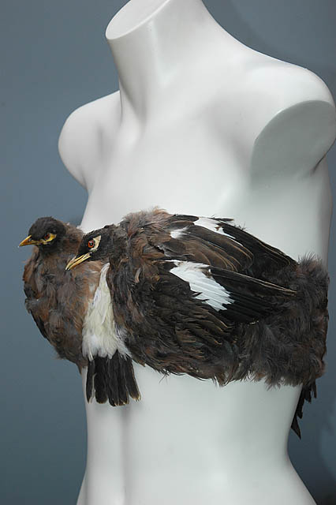
New Fashion Item
One of our Committee members has come across an unusual use for mynas as a fashion accessory. She didn’t believe it was modeled at the recent Sydney Fashion Week, but who knows: there are plenty of mynas up there that could be put to good use. I can’t see this fashion catching on, though.

WIN TV Coverage
In the last Bulletin, we reported that the local WIN TV news had a good item on Indian Mynas in Canberra and what we are doing about it. A few weeks ago, the WIN TV Sunday program had a long item on the problem of Indian Mynas, with a particular focus on the problem in Sydney and on the Central Coast. Peter Blythe and Matthew Whitehouse from the Central Coast Indian Myna Action Group Inc featured heavily. It was an excellent item and Peter and Matthew did the cause proud. The Central Coast group are ahead of us in a few areas, including the area of tax deductibility for donations: this is something we have on our agenda to organize in the months ahead.

Developments elsewhere

There have been some very good developments on the myna control front across eastern NSW.

Anna Hernell of the Shoalhaven City Council has been building a network of contact points across the shire for people to be the focal point for myna control in their area. This is to be a step in developing community-action programs across the shire. The Sussex Inlet Men’s Shed is building myna traps – to our PeeGees design – for distribution to prospective trappers in the Nowra area. Anna has done a tremendous job in getting this movement going down there.
The Far South Coast Birdwatchers Group has been very active in trapping Indian Mynas across the district in an effort to minimise the chance that their numbers will grow as they have elsewhere. Jim Shields is coordinating the job and with helpers from the birding group and other local groups has built a number of large traps - a modified Tidemann design - that are being put to good use. Because myna numbers are lower down there, it takes more work to catch them, but it is well worth the effort. A myna-free Far South Coast would be a delight to see - and hear.
Trappers in Newcastle have been continuing to have success. Reports in from new trappers tell the story of easy pickings – so to speak.
The Tamworth Birdwatchers Group and the Tamworth Council have been working together to tackle the local problem of Starlings and Mynas, with excellent success. John Holland reports that they have now removed approx 1200 starlings and 800 mynas, with most (about 1,500) being caught by the Tamworth Regional Council using a large trap - around 4m long, 3m wide and 2m high which uses 10 of our PeeGees traps on the perimeter to entice the birds in: the crew at the Waste Services Group, TRC, have got it set up at the garbage depot.
The Coffs Harbour-based conservation group, Ulitarra Conservation Group, has been hard at work as well. Ron Smith reports that after reducing the myna numbers to just a few small pockets, they had an influx of mynas – no doubt blow-ins from the south wanting a holiday. Their 35 trappers are continuing to remove over 100 a month of these new interlopers. And they have been getting Work-for-the-Dole recipients to make traps for their members.
The Nambucca and Hastings River Landcare Groups are also getting very good captures. The Northern Rivers Landcare Network, which meets every six months, now has myna control activity as a regular agenda item. Councils and the Northern Rivers Catchment Management Authority up there are right behind this community movement: so myna control has become a mainstream activity up there.

CIMAG membership numbers
CIMAG numbers are approaching the 500 mark. Currently we have 477 members and the race is on to be the lucky 500th member, who will no doubt be overwhelmed with the wonderful door prize!

Tim Deveson’s refined trap for the wary or smart ones

Tim Deveson’s “Tiny Tim” trap plans will be shortly put on our website. But remember that you should only go to the trouble of building it if you have cleaned out most of your local mynas and only have a few “wary” or “smart” ones left. These are the ones that go part way in and then back out, or have worked out that the entrance tunnel is also an exit tunnel.

People have reported success with the Tiny Tim, but as it needs to be re-set after each single bird capture, it is best to use it when the PeeGees trap has cleaned up the others.

Trapping Information

Our reported trapping numbers now stand at 17,044 as at the end of March 08. However, it would appear that we have not got all the March reports in that we would expect. So a special plea: can you get those monthly reports in. It is important to get as accurate a figure on the numbers being removed so as to assist in assessing our impact and to answer any lingering doubts by some that we are only skimming off the “myna cream”. Also if you lend your trap or know of anyone who is trapping but who doesn’t send in their reports, can you please ask them to do so (either to me on 6231 7461 or handke@grapevine.net.au or to Peter Green our trapping collator on peegee@actewagl.net.au . And please, get them to join CIMAG. High membership numbers can be used to impress governments that people want support and action on this serious problem.
The trapping data for the last few months is:

Suburb Jan -March 08 Aggregate Mynas Suburb Jan –March 08 Aggregate Mynas
Amaroo 73 194 Aranda 17 525
Ainslie 138 171 Banks 3 61
Barton 0 0 Belconnen 0 31
Bonython 0 25 Bruce 0 8
Calwell 0 77 Campbell 16 63
Chapman 20 176 Chifley 0 172
Chisolm 0 0 Conder 0 81
Cook 22 33 Curtin 163 439
Deakin 5 169 Dickson 0 4
Duffy 129 528 Dunlop 0 53
Evatt 30 110 Fadden 58 313
Farrer 6 305 Fisher 102 437
Florey 0 38 Flynn 34 219
Forrest 0 36 Garran 73 554
Gilmore 25 25 Giralang 109 348
Googong 0 56 Gordon 0 247
Gowrie 0 0 Greenway 0 0
Griffith 27 31 Hackett 15 125
Hall 153 883 Hawker 25 191
Higgins 33 33 Holder 16 60
Holt 107 109 Hughes 121 504 Isaacs 0 35 Isabella Plains 0 11 Jerrabomberra 0 79 Kaleen 207 423
Kambah 198 3802 Karabar 0 13
Latham 58 106 Lyneham 42 101
Lyons 99 493 Macarthur 0 8
Macquarie 50 257 McGregor 0 17
McKellar 0 40 Majura 0 1
Mawson 0 31 Melba 0 63
Monash 77 263 Narrabundah 113 361
Ngunnawal 3 89 Nicholls 0 96
O’Connor 5 5 O’Malley 0 17
Page 0 14 Palmerston 0 0
Pearce 43 546 Queanbeyan 13 46
Red Hill 7 95 Richardson 0 83
Rivett 80 265 Royalla 0 0
Scullin 0 4 Spence 0 5
Stirling 37 159 Sutton 0 0
Swinger Hill 0 13 Theodore 38 674
Torrens 5 127 Turner 1 23
Wanniassa 76 405 Waramanga 54 416
Watson 0 227 Weetangera 10 190
Weston 57 290 Yarralumla 13 196
Yass 0 0

CIMAG News Distribution System

To get onto the CIMAG news email distribution system for news and notices from the CIMAG Committee, just send a blank email to news-subscribe@indianmynaaction.org.au and you will be automatically included on the distribution list. This will be the main way that the Committee will circulate information and notices to CIMAG members and “friends”.

Bill Handke
President
CIMAG
16 May 08

