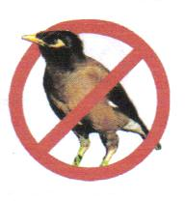

Myna Matters Bulletin # 12

Dear CIMAG Members and Friends

The following provides an update on CIMAG activities.

Greetings and Best Wishes for 2008

We trust that you had a most enjoyable Christmas break and that 2008 has started well for you.

This year will need to be a busy year for CIMAG: with the grants from the ACT and federal governments we will need to undertake a fair bit of pubic education work and get a large number of traps built and distributed out to the public. We are mapping out a program of work – and will keep you informed of developments. From time to time we are likely to seek your direct help in getting things moving.

Getting the Message Out – our new information sheets

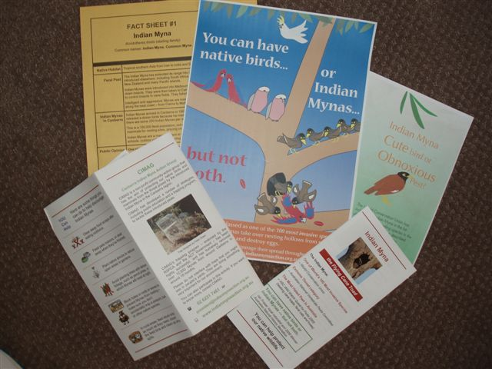
With the funds provided from the ACT Government Environment Grant and the federal government’s EnviroFund, we have had information brochures, pamphlets and a mini poster made up. We will be developing more of these, targeted at specific audiences: business, restaurants and cafes, schools and the general public. The intention is to distribute these through community groups, government shop-fronts and through schools etc. If you know of suitable groups (conservation / environmental groups, gardening groups etc) that would be suitable outlets to get these out to the general public, please let us know. The brochure and poster look brilliant. Our special thanks to Jane Tuckwell and Marie Lake for their sterling efforts: its good to have professional writers and graphic artists amongst our group.

PHD Student Selected - starting in February

The PhD student who is to undertake a 4 year research project and thesis on Indian Mynas has now been selected by the ANU project managers. We understand the student is to commence work in February. The project is extremely important follow-up research to that of Dr Tidemann. It will provide valuable scientific data and knowledge about myna impacts and myna control. The precise nature of the project is yet to be developed. Even so, it is anticipated that CIMAG members / trappers will have a role in supporting the student in aspects of the research field work.

On a not-unrelated matter, we would like to hear from CIMAG members who are also COG members and who are filling out the COG Garden Bird Survey. Could you also please advise whether you are also trapping or know of people in your area who are trapping. It is time we brought these two aspects together much more closely than we have in the past. The results of the Garden Birds Survey may be useful in demonstrating, or otherwise, the impact of trapping at the local scale on myna numbers and any change in small native bird numbers. If you are a COG GBS monitor and a CIMAG trapper please contact me on 6231 7461 or email handke@grapevine.net.au.
WIN News – good coverage on CIMAG and Indian Mynas

We were approached recently by WIN TV News for an item on Indian Mynas - this came at the suggestion to WIN from one of our members. WIN TV News gave us and the myna problem very good coverage on Tuesday 8th January. As a result we have had quite a few inquiries about what to do to tackle this problem. All good positive stuff.

Gungahlin Sustainable Living Fair – a most successful day

CIMAG was invited to participate at the inaugural Sustainable Living Fair that was held at Gungahlin in early Dec. It was a great success with some thousands of people coming through the various information booths. There was a lot of interest in our stall, where we had brochures and pamphlets to give out and a couple traps (the PeeGee trap and the MiniMyna trap) on display. Quite a few people joined the group and there were lots of orders for traps.

Thanks to Rosemary Blemings and Peter Ormay who “personed” the booth with me.

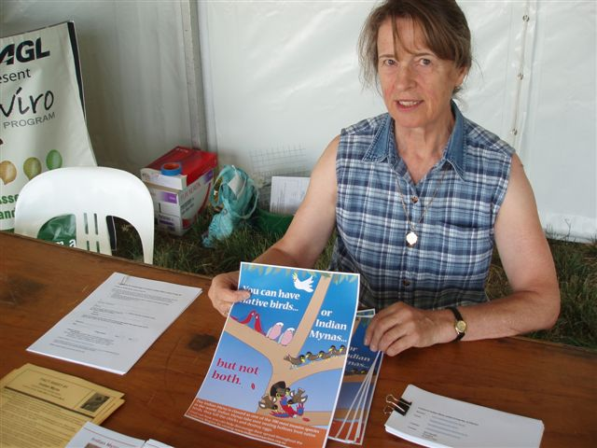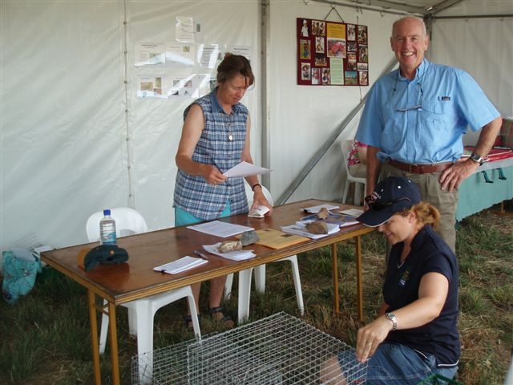

Rosemary with our poster. Rosemary with Chris Davey, President Canberra Ornithologists Group, and Shelley Cooper of the Ginninderra Catchment Group

Developments elsewhere

There has been a lot of media publicity about the Indian Myna problem in Newcastle of late. A consequence has been that we have been getting calls and emails from people wanting to know what they can do up there. A few people up there have been trapping with an array of traps and getting some good numbers.

The Tamworth Birdwatchers Group and the Tamworth Council have been working together to tackle the local problem of Starlings and Mynas, with some initial success.

The Coffs Harbour-based conservation group, Ulitarra Conservation Group, has been hard at work as well. Ron Smith reports that they have removed 1400 mynas from around Coffs and they are now becoming scarcer – only small pockets of them left, which is wonderful news. Also Ron reports that people in Port Macquarie have removed over a thousand mynas as at a month or so ago, and that activities in Kempsey and Nambucca are progressing well.

Around the Mid North Coast of NSW, the North Coast Myna Project - established by a collation of landcare and environmental groups with support from local councils - has recently developed a Myna Handbook and other education materials – really useful stuff. You can access the Handbook through their website, www.indianmyna.org . Alana Parkins, the coordinator for the project, also reports that the group is developing new traps for specific sites. The most recent is for a stock feed distributor on the Pacific Highway north of Taree where some hundreds of mynas gather each day.

Trapping Information

Members around Canberra / Queanbeyan / Jerrabomberra / Royalla are reporting seeing lots of juveniles flocking together. At this time of the year they seem to form “crèches” and tend to be easy to trap: young and naïve, I guess. So now is the time to get your trap out: catch the young ones before they wise up. Remember though, that with the hot weather, it is important to have some cover over the trap and to keep the water in the trap fresh and topped up.

Our reported trapping numbers now stand at 14,195 as at the end of Dec 08. Trapping data for the last few months is: August 404; Sept 326; Oct 568; Nov 270; Dec 856.

The big trapping news is two outstanding returns in Dec: 102 mynas caught by a member in Duffy and 105 by a trapper in Kaleen. Suburb captures are included later in this bulletin.

This may not include all the December captures, so if you haven’t had a chance to send your December captures through to Peter Green or myself, could you please do that.

Also, if you are taking mynas to the RSPCA for disposal, could you also please inform us of your captures. A recent check with the RSPCA indicated that they disposed of 651 mynas during 2007, of which quite a few were from 23 people that we had no knowledge of or contact with. So, if you are lending your trap on or a friend is making a copy of yours, it would be greatly appreciated if you would ask that person to join CIMAG and to sign the Protocol on Animal Welfare.
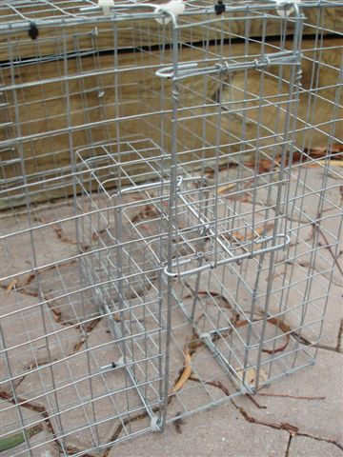
Tim Deveson’s refined trap for the wary or smart ones

Tim Deveson has worked up a compact drop-door trap (“the Tiny Tim”) to catch those few remaining wary ones who only go part way in and then back out, or the really smart ones that have worked out that the entrance tunnel is also an exit tunnel.

He has donated four of these gems to CIMAG for us to lend out to people who have this problem.

As it has to be re-set after each single bird capture, it is suitable only to try to catch the wary or smart mynas. Get in touch with me if you want to borrow it to clean up any in this category.

The trap is essentially the feeding chamber of our usual PeeGees trap with a modified tunnel of a drop-down door, based on the treadle-trigger concept of a cat or possum trap. Very smart work by Tim. It is difficult to draw up plans for,
The Tiny Tim
although he is working on it.

RSPCA Hours for Disposing of Trapped Mynas
If you don’t want to euthanise trapped mynas at home (using carbon monoxide from the exhaust of a cold car as per our protocol) and would prefer to have them disposed of at the RSPCA, the times to take them to the RSPCA Centre are:
Monday: 10:00am – 11:00am and 4:30pm – 5:30pm
Wednesday: 4:30pm – 5:30pm
Friday: 4:30pm – 5:30pm.

Please take the trapped mynas / starlings to Building A, the Wildlife Building at the RSPCA Centre — it is the very first building in the RSPCA complex as you come down Kirkpatrick St in Weston. If bringing mynas and starlings to the Centre for disposal, could you please use an opaque bag or box in view of possible sensitivity of some people to trapped birds.
Myna Capture Details by Suburb

Suburb Aug-Dec 07 Aggregate Mynas Suburb Aug-Dec 07 Aggregate Mynas
Amaroo 62 121 Aranda 26 508
Ainslie 1 33 Banks 58 58
Barton 0 0 Belconnen 22 31
Bonython 0 25 Bruce 0 8
Calwell 0 77 Campbell 1 47
Chapman 59 156 Chifley 0 172
Chisolm 0 0 Conder 58 81
Cook 11 11 Curtin 109 276
Deakin 32 164 Dickson 0 4
Duffy 112 399 Dunlop 14 53
Evatt 2 80 Fadden 44 255
Farrer 48 299 Fisher 205 345
Florey 32 38 Flynn 46 185
Forrest 5 36 Garran 82 481
Gilmore 0 0 Giralang 16 239
Googong 0 56 Gordon 29 247
Gowrie 0 0 Greenway 0 0
Griffith 0 4 Hackett 62 110
Hall 37 730 Hawker 14 166
Higgins 0 0 Holder 24 44
Holt 2 2 Hughes 22 383 Isaacs 0 35 Isabella Plains 0 11 Jerrabomberra 12 79 Kaleen 140 216
Kambah 134 3604 Karabar 0 13
Latham 0 48 Lyneham 29 59
Lyons 62 394 Macarthur 0 8
Macquarie 21 207 McGregor 0 17
McKellar 0 40 Majura 0 1
Mawson 31 31 Melba 9 63
Monash 63 186 Narrabundah 40 248
Ngunnawal 45 86 Nicholls 0 96
O’Malley 5 17 Page 14 14
Palmerston 0 0 Pearce 47 503
Queanbeyan 0 33 Red Hill 20 88
Richardson 0 83 Rivett 17 185
Scullin 0 4 Spence 0 5
Stirling 86 122 Sutton 0 0
Swinger Hill 0 13 Theodore 84 636
Torrens 78 122 Turner 0 22
Wanniassa 71 329 Waramanga 39 362
Watson 0 227 Weetangera 16 180
Weston 8 233 Yarralumla 24 183
Yass 0 0

CIMAG News Distribution System

To get onto the CIMAG news email distribution system for news and notices from the CIMAG Committee, just send a blank email to news-subscribe@indianmynaaction.org.au and you will be automatically included on the distribution list. This will be the main way that the Committee will circulate information and notices to CIMAG members and “friends”.

Bill Handke
President
CIMAG
19 Jan 08

