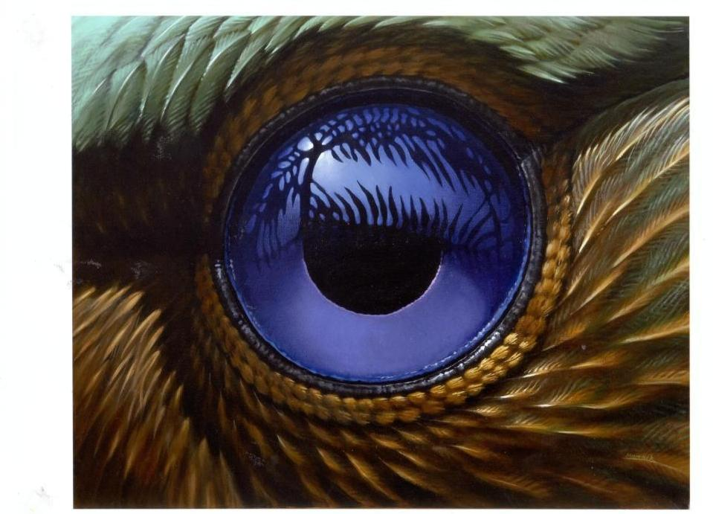

Wildlife Art @ Discovery

Wildlife and Botanical Artists Incorporated invites you to attend
the inaugural Wildlife Art @ Discovery, a national exhibition to encourage an appreciation of Australian wildlife through artwork and sculpture.

Opened by Dr. Richard Schodde, eminent Australian ornithologist
Friday 29 June at 6.00 for 6.30pm
CSIRO Discovery Centre, Black Mountain, Canberra

Exhibition continues from Saturday 30 June to Sunday 8 July
Hours Weekdays 9 – 5
Weekends 10 – 4

Visit www.waba.net.au for on line sales from 9 to 31 July 2007

