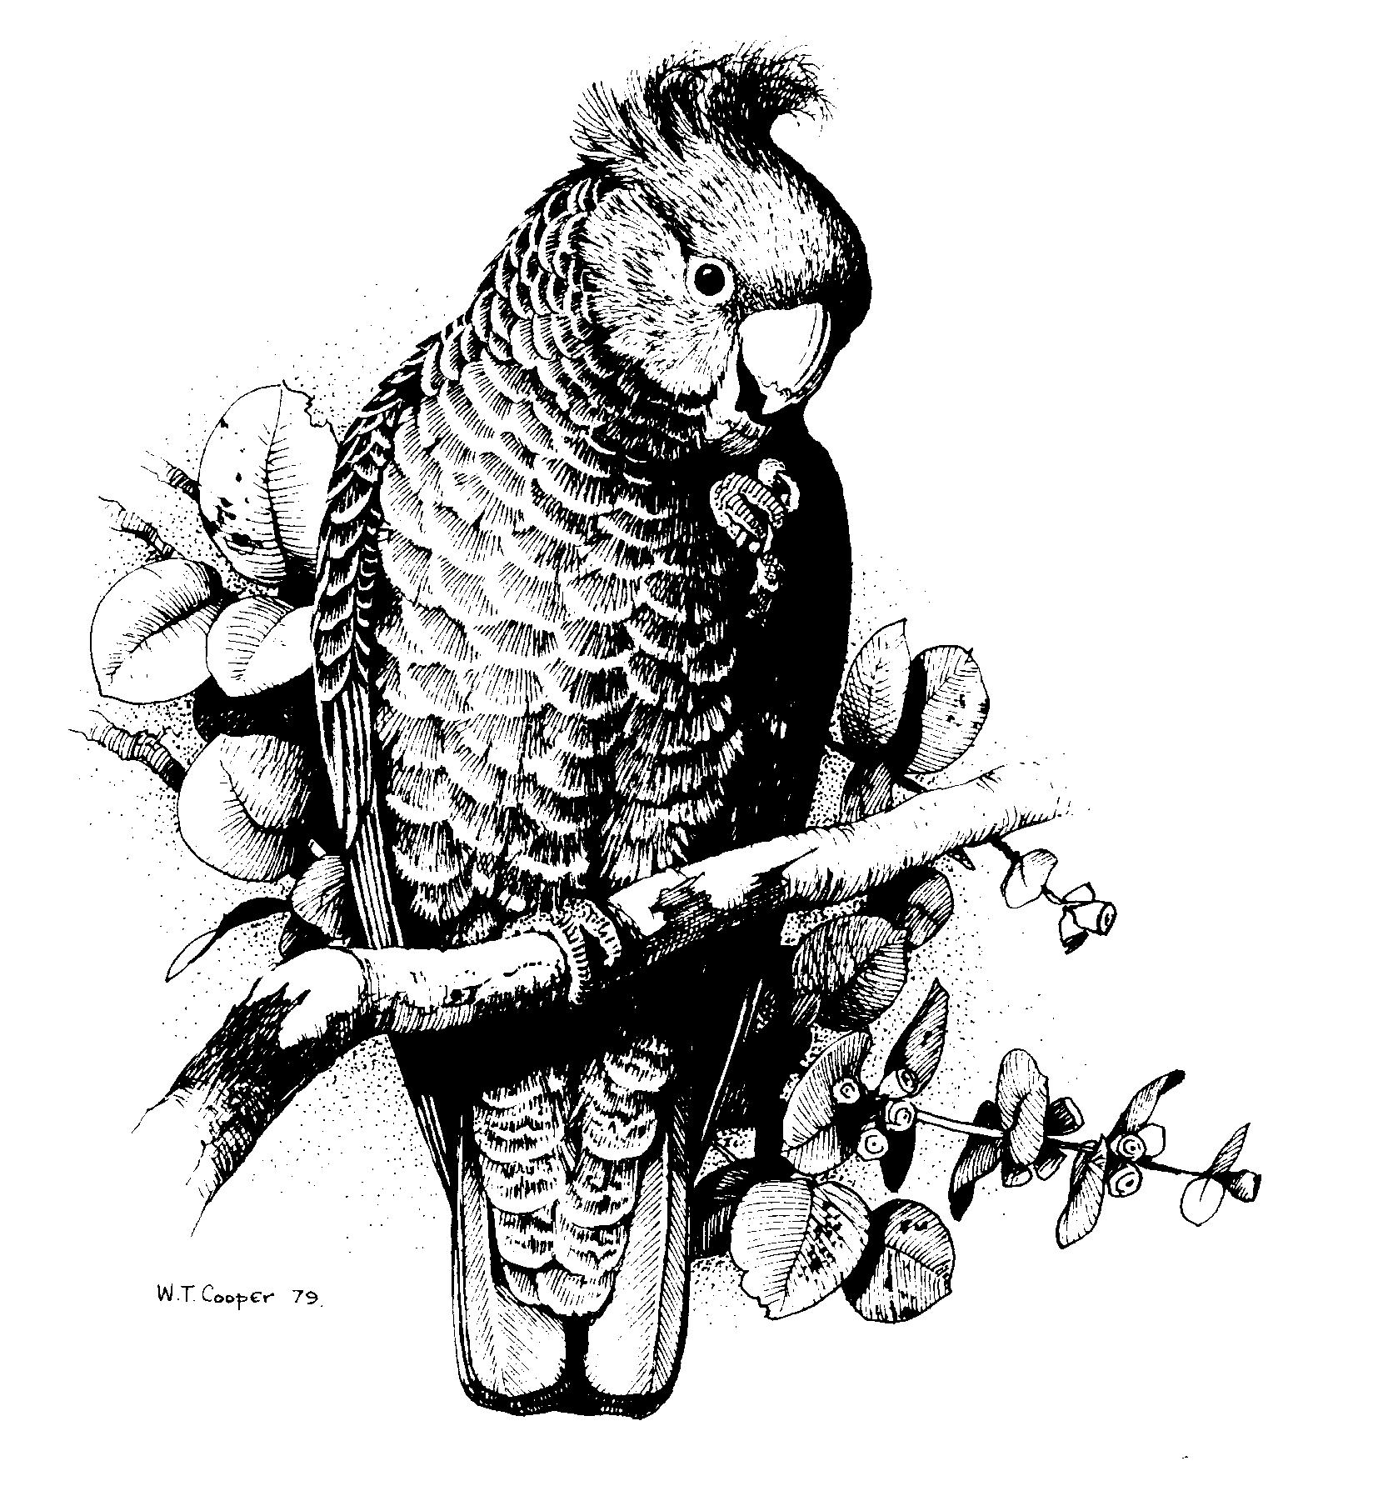

Garden Bird Survey Questionnaire

All contributors to the Canberra Ornithologists Group’s
Garden Bird Survey,

After more than 25 years and the production of two publications the time has come to review the Garden Bird Survey (GBS). A Sub-committee has been established to undertake that review and plans to report to the COG Committee by 31 December 2007.

The Review Sub-committee wishes to obtain some details on how present and/or past contributors to the GBS collect the data. The Sub-committee would be grateful if you would spend a couple of minutes filling in the questionnaire on the reverse of this letter and either hand in the form to Martin Butterfield or Chris Davey at the monthly meeting or post to

Canberra Ornithologist Group Garden Bird Survey,
P.O. Box 301,
Civic Square,
ACT 2608

Please note that in the context of this questionnaire we are not interested in who you are, or where you contribute from and have deliberately designed the questionnaire to be anonymous. We are only interested in how observations are collected and recorded, irrespective of whatever the "rules" may say.

In a similar vein we would prefer that, at this stage, all discussion be on a one on one basis between GBS observers and a member of the Sub-committee rather than through more public forums such as the chat-line.

For any points of clarification please contact:
Martin Butterfield 02–6238 2637 (h), email martinflab@gmail.com
Chris Davey 02-62546324 (h), email chris_davey@aapt.net.au

Garden Bird Survey Review Sub-committee:

Martin Butterfield
Chris Davey
Michael Lenz
Nick Nicholls

1.1 | How many years, in total, have you contributed to the GBS? | 1-2,  3-5,  5-10,  >10
1.2 | Have you contributed over the past 5 years? | Yes  No
1.3 | How many years have you contributed at your most recent/present site? | ____ years
2 | Have you changed the shape of your survey area at your most recent/present GBS site? | Yes  No
3 | Do you count species flying >100m above the site? | Yes  No
4 | Do you count species that you have heard and not seen? | Yes  No
5 | Do you count species passing through but not using the site? | Yes  No
6.1 | If for any one week you are away for 6 days do you record the species seen on the one day at home? | Yes  No
6.2 | If for any one week you are away for 6 days do you cross out the week number at the head of that column? | Yes  No
7 | For your most recent/present GBS site, how did you assess the size of the site? | Estimated by eye  Paced out  Measured off map
8 | How many individuals would you record if you saw an adult male and female Australian King-parrot not together but:
 | 8.1 Within 30 seconds of each other? | 1  2
 | 8.2 Within 5 minutes of each other? | 1  2
 | 8.3 On different days within the GBS week? | 1  2
9 | Please list the five bird species which present the greatest difficulty in assessing the numbers of birds on your site at any one time. | 1
9 |  | 2
9 |  | 3
9 |  | 4
9 |  | 5
10 | Any comments on GBS?

