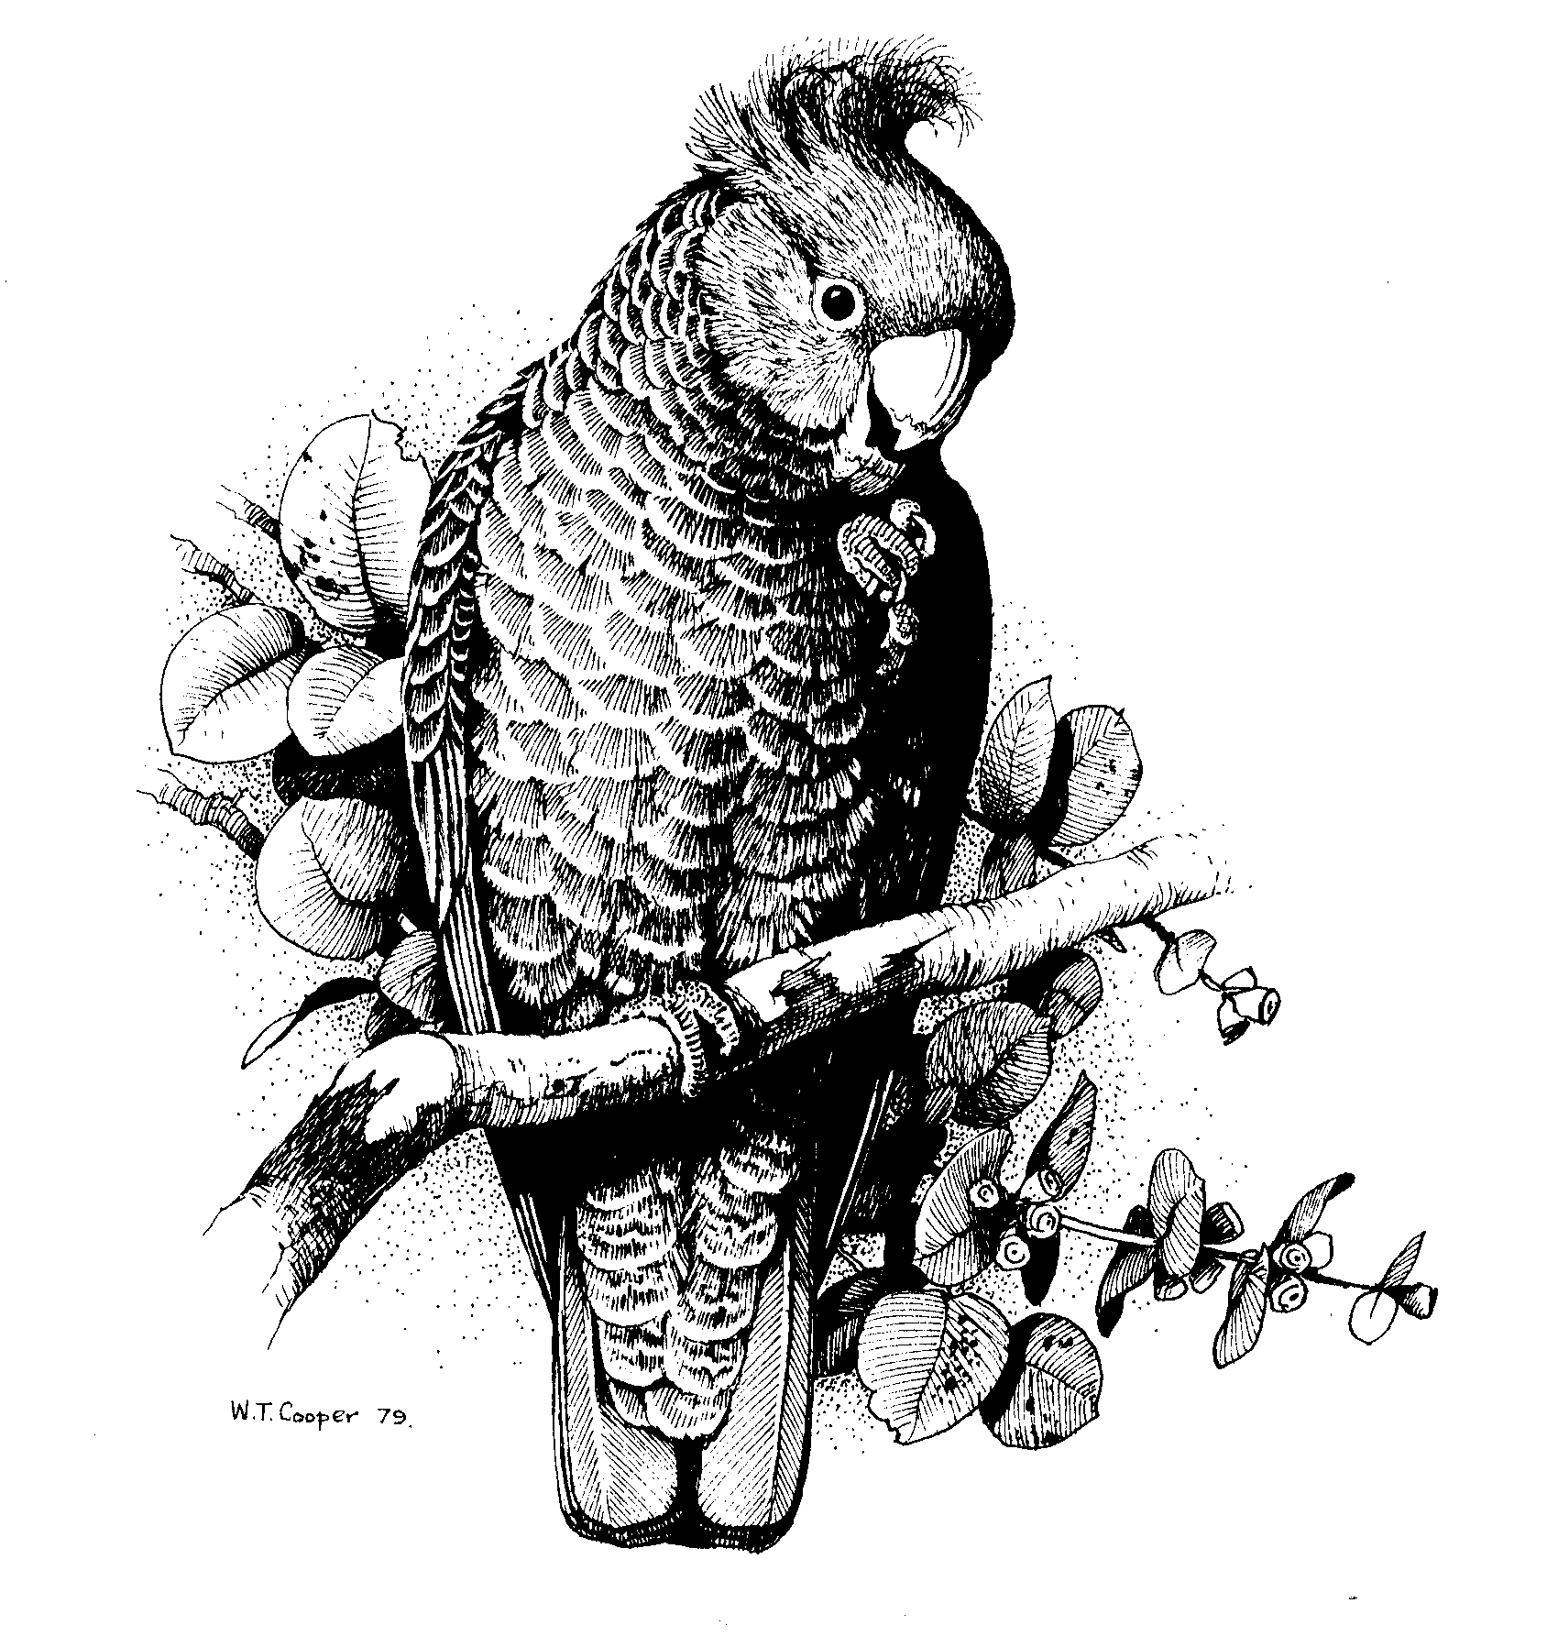Canberra Ornithologists Group
PO Box 301

CIVIC SQUARE ACT 2608

ABN 72 534 628 789

Mr Ray Brown
Principal Officer – Belconnen and West
Development Assessment Team
Development Services Branch
ACT Planning and Land Authority
GPO Box 1908
Canberra, ACT, 2601

Dear Mr Brown

Proposed Feral Proof Fence at Mulligan’s Flat Nature Reserve – Block 737 Gungahlin – Preliminary Assessment

I am responding on behalf of the Canberra Ornithologists Group (COG) to the opportunity to comment on this PA.

COG is supportive of the research project which is being conducted by the Australian National University/CRES and the ACT Government at the Mulligan’s Flat and Goorooyarroo Nature Reserves, which includes the predator proof fence as part of the experimental research. We believe this will have very important outcomes for research and conservation on grassy woodlands ecology, as well as for community education and the long-term protection of the reserves, which will outweigh any minor impacts which might occur, eg due to the loss of a small amount of native vegetation/forest type habitat.

While COG does not wish there to be delays in the PA process and the construction of the fence, some COG members have made the observation that the PA is generally lean on the impacts on ecological processes/animal species which are resident in the reserve and may be affected. We appreciate that Environment ACT and the ANU/CRES research have undertaken survey work/inventories in the reserve and the animal and bird species are well known, but the PA could be strengthened to clearly demonstrate there has been consideration of impacts on particular species of animals, such as the ACT threatened birds and main animals (2 species of kangaroos, wallaby, echidna etc). We note that a comprehensive assessment has been made of aboriginal and heritage issues and included in the PA.

In terms of possible impacts on birds from the fence or the small loss of trees, these are considered likely to be very minor overall. However, we recommend that the PA include a list of the threatened ACT birds found in the reserve (Hooded Robin, Superb Parrot, Varied Sittella, White-winged Triller, Regent Honeyeater, Painted Honeyeater and Brown Treecreeper (thought to be recently extinct in the reserve), together with a brief impact assessment statement etc, eg Superb Parrots use large areas of the landscape and are known to be very fast flyers – any issue of possible collision?

The PA could usefully include/flag:
- A plan should be developed for dealing with the large Eastern Grey Kangaroo population, how this will be managed as the fence is closed off, eg how many to remain in etc, and how numbers enclosed will be managed in the longer term
- What is proposed to protect animals enclosed in the event of a large-scale wildfire within the fenced area
- How effective the fence will be in reducing breaches by predators.

Should brief comments from the Conservator of Flora and Fauna about loss of native vegetation and the impact assessment on threatened birds and significant animals have been included, as is usually the case with PAs where there are threatened species or ecological communities?

We have a query regarding the Swift Parrot to be a ‘known inhabitant’ of the reserve (page 6). COG has never recorded this species at Mulligan's Flat, although there is potentially suitable habitat; possibly it is meant to be Superb Parrot?

It is also recommended that the PA include the requirement for a detailed plan and standards to be set for the contractors in the construction phase, to absolutely minimise disturbance and the possibility of weeds being introduced into the reserve.

Yours sincerely

Jenny Bounds
Conservation Officer
24 December 2006

