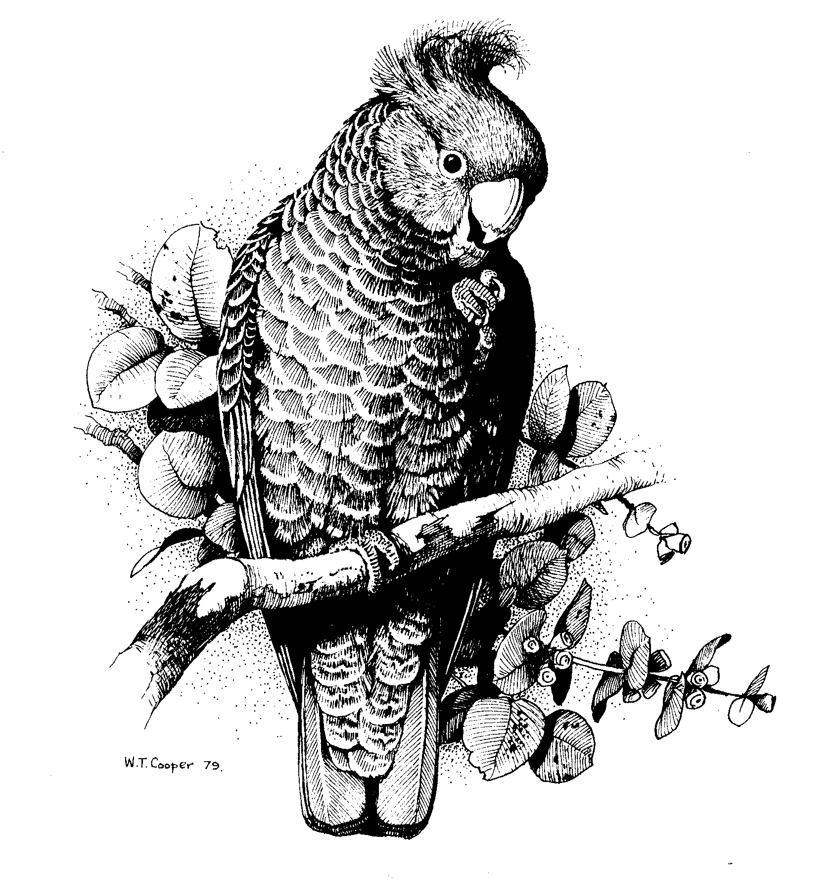Canberra Ornithologists Group
PO Box 301

CIVIC SQUARE ACT 2608

ABN 72 534 628 789

The Molonglo Valley Project Team
ACT Planning and Land Authority
GPO Box 1908
CANBERRA ACT 2601

Dear Project Team

Molonglo Valley Structure Planning Study

I am writing on behalf of the Canberra Ornithologists Group (COG) in response to the release of this Study and the invitation to the community to provide comments. Due to the broad nature of the details made public, and in the time available, these comments are necessarily brief.

COG is dedicated to the study and conservation of native birds and their habitats. COG is essentially concerned with better protection for native vegetation which provides habitat for various species of birds, especially birds which are associated with grassy woodlands. COG surveys and research show that a number of woodland bird species continue to decline in abundance, including birds which are listed as threatened under ACT legislation. The primary cause is the overall loss of woodland habitat and fragmentation of habitat, overlaid by a variety of other pressures and threats including urban related pressures.

While our Group does not oppose utilising the footprint of the former (burnt) pine forest area in the East location for urban development, COG is generally disappointed with the Structure Plan which we believe will impact negatively on a large and diverse population of birds of prey in the Molonglo Valley as well as woodland birds, including threatened species. We do not support development which would destroy or significantly alter the mosaic of woodlands, grasslands and riverine ecosystems and rural lands in the Valley, which make up important bird of prey habitat as well as habitat for the assemblages of birds and animals which provide their prey base.

COG is particularly concerned about the following issues:

- The Valley is an important hunting and breeding ground for 12 species of birds of prey. We understand this is an area unique to Canberra, and indeed in the Australian SE highlands, in its number and diversity of these species for a small area close to the city. Such a large number of birds of prey indicates a large assemblage of other fauna including birds live in the habitats in the Valley”
- further studies relating to the impacts of urban development on these birds of prey have not yet occurred; we are especially concerned that these have not been carried out prior to the announced Structure Plan; and
- the proposed Structure Plan is likely to have a significant and negative effect on the habitat for these birds.

- Development in the central area is likely to impact negatively on birds in the Kama woodlands, especially the threatened Brown Treecreeper of which a small population still occurs there; Brown Treecreepers have also been recorded in the nearby Pinnacle NR:
  - This species has managed to survive in small numbers in this relatively undisturbed location over some years (COG surveys in the 1980s confirm the presence of a small population of the birds then);
  - This species has progressively disappeared from other woodlands around the urban fringes of Canberra as urban development has spread and reduction and fragmentation of habitat has progressed;
  - even in the largest woodland reserves of Mulligan’s Flat and Goorooyarroo, Brown Treecreepers have declined and are now likely to be extinct in those reserves;
  - The small population of threatened Brown Treecreepers in the Kama woodlands is unlikely to survive there into the longer term under this Structure Plan with urban development on both sides of the woodland;
- To better protect the Kama woodlands development should NOT occur in the central area; this area should remain as ‘broadacre’ use, or development should be limited to the northern part of the area; and
  - At the very least, a study should be undertaken of the likely impact on Brown Treecreepers in Kama from the Molonglo Valley development.

- An inadequate wildlife corridor is proposed between the central and east areas through the Kama woodlands to the Pinnacle and Mt Painter Nature Reserves; to conserve the significant variety of birds in this corridor. This needs to be significantly wider or preferably no development should occur on one side (eg no development or limited development in the central area – see above).

- Again while not opposing utilising the footprint of the former (burnt) pine forest area in the East location for urban development, COG remains concerned about urban impacts from the east location, on the Molonglo River Corridor, and the pond/lake proposal as well as a Group Centre being established right on the River:
- The sensitive river corridor should receive the maximum protection from urban effects, rehabilitation of degraded areas could be undertaken, and there should be a much wider buffer established between the urban areas and the river corridor;
- The River Corridor is a thoroughfare for birds, particularly small birds on migration, as well as providing nesting sites for birds of prey;
- Development and destruction of habitat near the river is likely to impact negatively on some species of birds and is likely to alter migration patterns of some species; and
- If options for a pond/lake on the river are to be developed, there should be a full environmental impact assessment undertaken prior to any development activity.

COG notes that the documents make reference to the central and western areas not needing to be developed in the foreseeable future, with the eastern area being favoured to take the substantial amount of the expected population growth. COG strongly recommends that the central area in particular, as well as the western area, are not developed at all.

COG also notes the preliminary and broad nature of the documents currently available, and looks forward to being able to comment in the future on much more detailed plans for particular areas and proposals as they are developed.

Yours sincerely

Jack Holland
President 29 November 2005

