MAGNIFICATION: ‘Magnification’ in relation to images is a relative concept. For comparisons, it is more useful to talk about the angle of view (in degrees) that is captured by the relevant equipment.

Start with binoculars. A pair that magnifies 10x shows you an image of the subject that is 10 times larger than what you would see with unaided vision, eg if you are looking at a bird 100 metres away the bird will appear the size that it would appear if you were looking at it from 10 metres away. However, ‘10x’ (contrary to what some think) does not correlate with a particular field of view. If you use ‘wider angle’ binoculars, you will see a larger field of view, at the same subject-magnification.

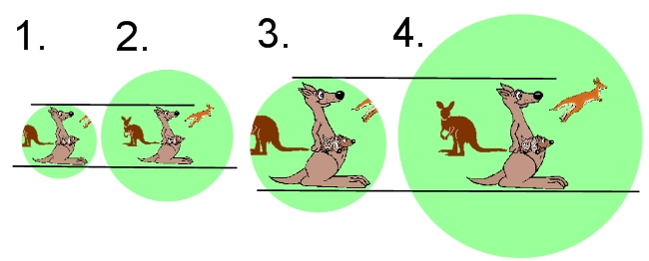

In the above series, 1. represents a view through narrow-angle (say 5 degrees) 6x binoculars; 2., wide-angle (say 10 degrees) 6x; 3., narrow-angle 12x; and 4., wide-angle 12x. In 2 and 4, Mrs Kangaroo is the same apparent size as in 1 and 3 respectively, but there is also more field in the image in 2 and 4. The field in the image is the same in 2 and 4 because both are 10-degrees binoculars, although the magnification is doubled in 4. [The reason that the 2 and 3 images are shown as about the same size is because of the coincidence that the step up in magnification and in field in the examples is a doubling in each case.]

With binoculars and telescopes, the ‘standard’ for the magnifying descriptor is what the unaided eye sees at the relevant distance. This does not apply to photography. The end result of photography is not a single image proportionate to the image seen by the unaided eye, but a variable image that might be printed the size of a postage stamp or projected enormously enlarged on the side of a building. The main purpose of the viewfinder is to show you the field that the camera will record.

To compare the relevant properties of various capture devices, it is appropriate to compare the relative size of the different field that each captures.

For reasons to do with the size of the film frame and what seemed to be a natural size in the viewfinder, a ‘50mm focal length’ was adopted as the standard in 35mm photography. A 50mm lens captures a rectangle with about 46 degrees of field on the diagonal. Shorter lenses (more glass, more cost) capture a proportionately wider field and longer lenses (also more glass, more cost) capture a proportionately narrower field. A 200mm lens (4 x 50mm) captures a field of about 12 degrees. Some might say, therefore, that a 200mm lens ‘magnifies’ 4 times, and that is the apparent increase in size of an object in the viewfinder, compared to a 50mm lens.

Smaller digital cameras and videocameras do not usually display information about the ‘length’ of the lens, but refer to the range of the optical zoom function eg 3x, 5x, 10x, 20x. This does not bear any necessary relation to the 50mm standard, but refers to the factor by which the closest zoom point exceeds the furthest, that is the widest field of view is divided by the narrowest.

Apart from the length of the lens, a factor that affects the field of view in digital cameras is the size of the sensor, which is usually smaller than a 35mm film frame. In most basic SLR digital cameras this means that the 50mm field is reduced to 29 degrees with a proportionate apparent increase of magnification of 1.6x for any given lens. In the digital mini-dv format the factor is 7.2x.

With so many digital means of capturing ever-smaller slivers of the normal field of vision the issue becomes more one of quality of what is captured rather how small the sliver can be made. [You could achieve a tiny (but poor quality) sliver if you photographed with a wide-angle lens through a crack in a doorway.] If you put the equivalent of a 400mm lens (eg a 200mm lens with a 2x converter) on a basic SLR digital camera, or if you use a fixed-lens digital camera advertising something like a 15x zoom compared to its wide-angle, you have an outfit that will capture a field of about 4 degrees. [If you put a digital camera on your telescope, you might be looking at 2 degrees or less.]

With the 4-degrees outfit will that small bird fill your viewfinder? The answer depends entirely on how close you are to the bird. If it is very close you will only get part of the bird. Close-range bird photography can produce good results, and there is much to be said for putting effort into getting close to birds (something beyond the scope of this note) rather than acquiring and carrying around gear that captures less than 4 degrees. With the camera on the telescope and your 2 degrees, you will probably have difficulty finding the small bird, particularly if it is moving around.

Now, if magnification is only zeroing-in on a small segment of the normal field of vision, you can achieve this by cropping down when you process your image. The small bird can fill your computer screen. This is similar to using ‘digital zoom’ in a camera, but is more conveniently done in your computer. Of course, in both cases you have only the number of pixels as in the uncropped bird-image, so the image will degrade to some extent, perhaps a lot.

However, this simply underlines that the issue is really one of the quality of the image. Cropping will exaggerate most faults in the original. The pixel count is important but is only one factor in quality. The uncropped bird in the telescope shot might have most pixels, but suffer from poor optics or camera shake. Things that might affect quality more than the amount of pixels include: how close the subject is to the camera; accuracy of focus; accuracy of exposure; lighting of the subject (amount, and kind, of light, and its evenness); movement of subject; attitude of subject; background; elimination of shake and vibration, eg by use of a tripod or stabiliser; quality and speed of lens; fineness of storage medium (equivalent of film speed). ##

