Informa

BBC News Tuesday, 1 February, 2005, 11:18 GMT

Feathered friends no bird brains
The term "bird brain" is out of date as birds' brains are just as advanced as mammals', scientists have said.
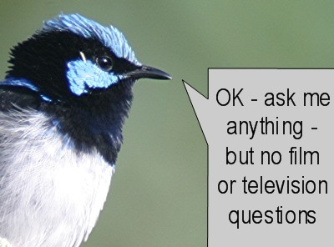
Calling people "bird brain" may be seen as a compliment
Birds can perform amazing tasks beyond the reach of cats and dogs, the Avian Brain Nomenclature Consortium of 29 world neuroscientists found.
Researchers spent more than 10 years studying behavioural patterns of birds around the world, to see if there was a link between bird and mammal brains.
Their findings are published in the journal Nature Reviews Neuroscience.
They said the findings could be used to study brain disorders like Alzheimer's.
In one study in Japan, pigeons were shown pictures by Picasso from his cubist period and impressionist Monet.
They were encouraged to peck a different key on a keyboard for each artist in return for food rewards.
There are lots of smart birds who do amazing things it would be difficult to get mammals such as rats or dogs to carry out
Dr Tom Smulders
Once they had mastered the technique they were given paintings by other cubist and impressionist artists.
The birds consistently came up with the correct answers.
Newcastle University's Dr Tom Smulders said: "Many people have outdated notions of what bird brains are like - but there are lots of smart birds who do amazing things it would be difficult to get mammals such as rats or dogs to carry out.
"Comparing birds with mammals can teach us a lot about how brains work."

