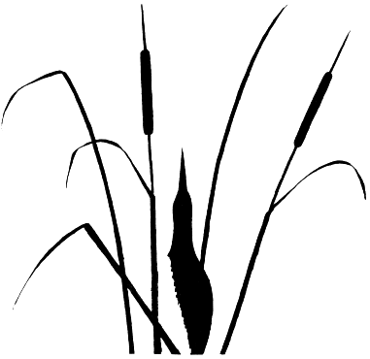Murrumbidgee Conference of
Bird Observers.
Griffith & Leeton
Friday 16th - Sunday 18th October 1998

Hosted by - Murrumbidgee Field Naturalists Inc.

The Murrumbidgee Field Naturalists Inc. presents the second Murrumbidgee Conference of Bird Observers which will provide a great opportunity to see the birds and other delights of the Mid Murrumbidgee and to exchange experiences with others.
Conference guest speakers and organised field visits will give participants an understanding and appreciation of the natural heritage in the Mid-Murrumbidgee region, particularly the Murrumbidgee Irrigation Area (MIA) and bordering dryland districts.
Program
The program is centred at Griffith in the heart of the MIA and Commences
Friday 16/10/98 at 12.15 pm. with a walk through the River Red Gum Forest on the banks of the Murrumbidgee River in search of the magnificent Superb Parrot. Meet at the NSW Agriculture Conference Centre Murray Rd. Hanwood (see map on back).

The Conference Formal Session will commence at 7.00 pm. and feature the guest speakers:-
Rick Webster - Consultant Ecologist - Ecosurveys - “the Superb Parrot”

Dr. Iain Taylor - Lecturer - ecology and conservation, Johnstone Research Centre, CSU-Albury. “Barn Owls and others”.
Followed by light refreshments at 10.00 pm.
Venue - Senior Citizens and Community Recreational Centre- off Yambil St Griffith (see map on back).

Field trips have been arranged for Saturday 17th & Sunday 18th and includes visits to The Lake Wyangan Wetlands (Campbell’s & Nericon Swamps), the Cocopara National Park, Pulletop Nature Reserve, Fivebough Swamp, the Brobenah Hills and other great birding venues.
These venues will allow participants to observe and appreciate the birds of our forests, woodlands and significant wetlands, as well as other significant aspects of the natural heritage of the Mid Murrumbidgee Area.

The Saturday night is a casual affair and commences at 7.00 pm., the evening includes :-
- a Pizza, Pasta & Plonk buffet dinner,
- an occasional address by Dr Geoff Barrett - Co-ordinator of the Birds Australia, new Australian Bird Atlas project and
- an opportunity for some great social interchange and exchange of interesting birding yarns.

Cost :- Registration & Conference Formal Session - $25.
The Saturday Night Affair - $20

All Welcome, for further information please contact
Bill Moller Ph - 0269 601341 - Fax 0269 630255 Postal - Bill Moller
Sue Chittick Ph - 0269 624079 PO Box 1087
Michael Schultz Ph & Fax- 0269 532541 - Leeton Griffith 2680

Early Registration will assist with the scheduling of field trips and catering, RSVP 2/10/98.

